*Lofi Sketchbooks*

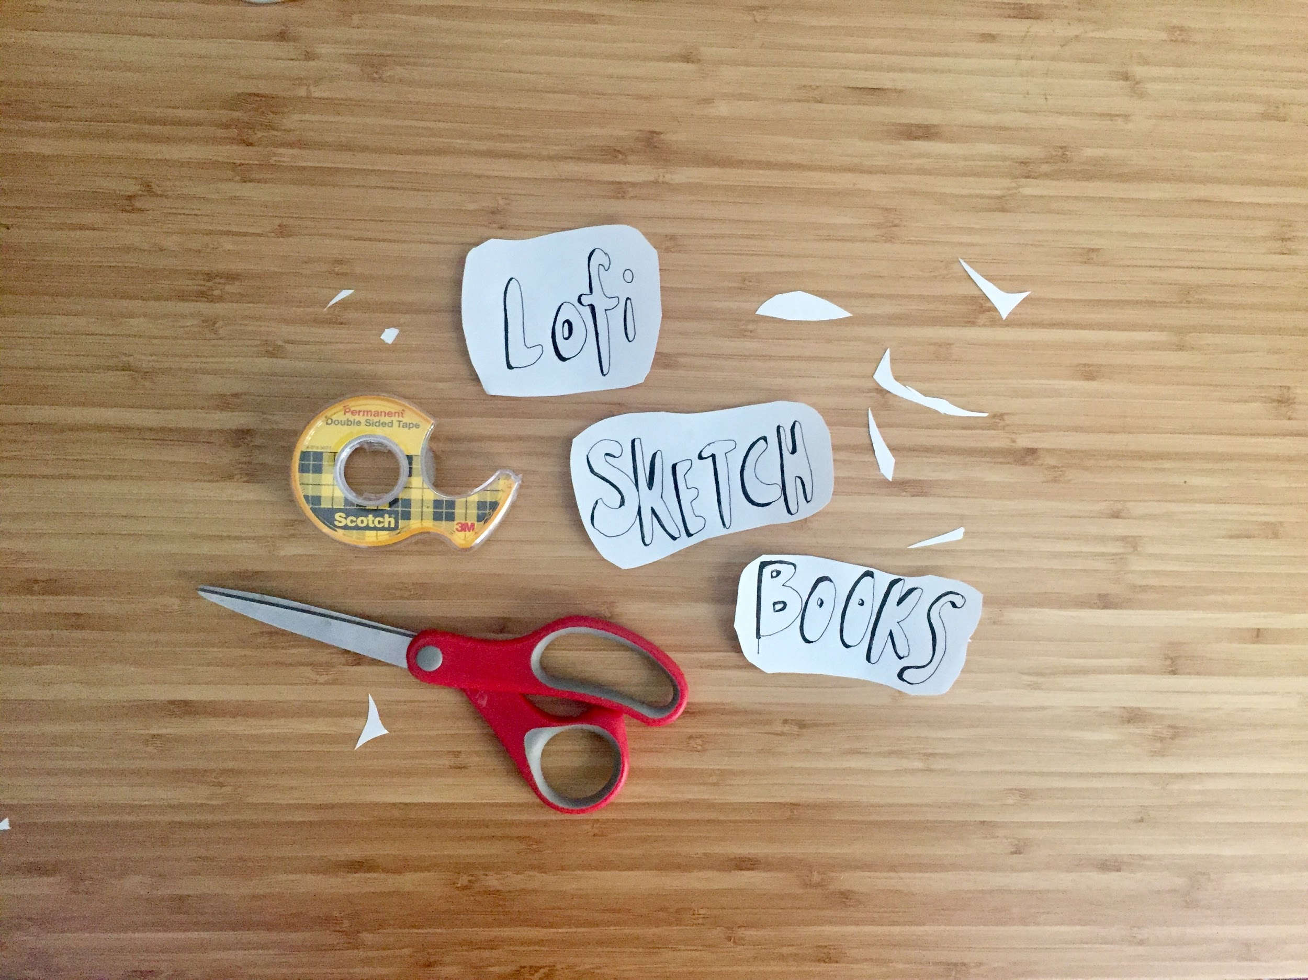

* 1-hr Workshop - [Teaching As Art Day](https://teachingasart.github.io/posts/teachingasartday/), Saturday March 2nd
* @ Elmer Holmes Bobst Library, 70 Washington Square S, New York, NY 10012
* 2:00-2:50pm
  + [Eventbrite Page](https://www.eventbrite.com/e/lofi-sketchbooks-tickets-57475673286#)
  + [WorkShop Slides](https://docs.google.com/presentation/d/1pFYqq-yOh4IP1_teSpcztjlq_o8z2NatwMf80XWN0BI/edit?usp=sharing)
  + [Follow-up Resources](https://docs.google.com/document/d/10TVjhkV6ZtcWlzG9-8AWE5F-NuCiZLbrYXHMbP-TMYY/edit?usp=sharing)  + [Treasuremap](https://drive.google.com/open?id=18odYB6hCbLemv0LTuXD2mOxdYgThV2KG&usp=sharing)

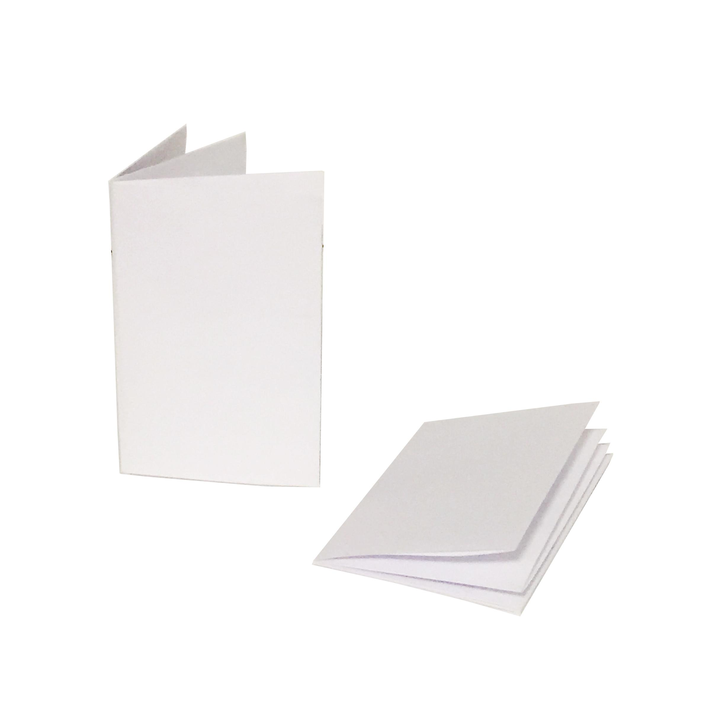

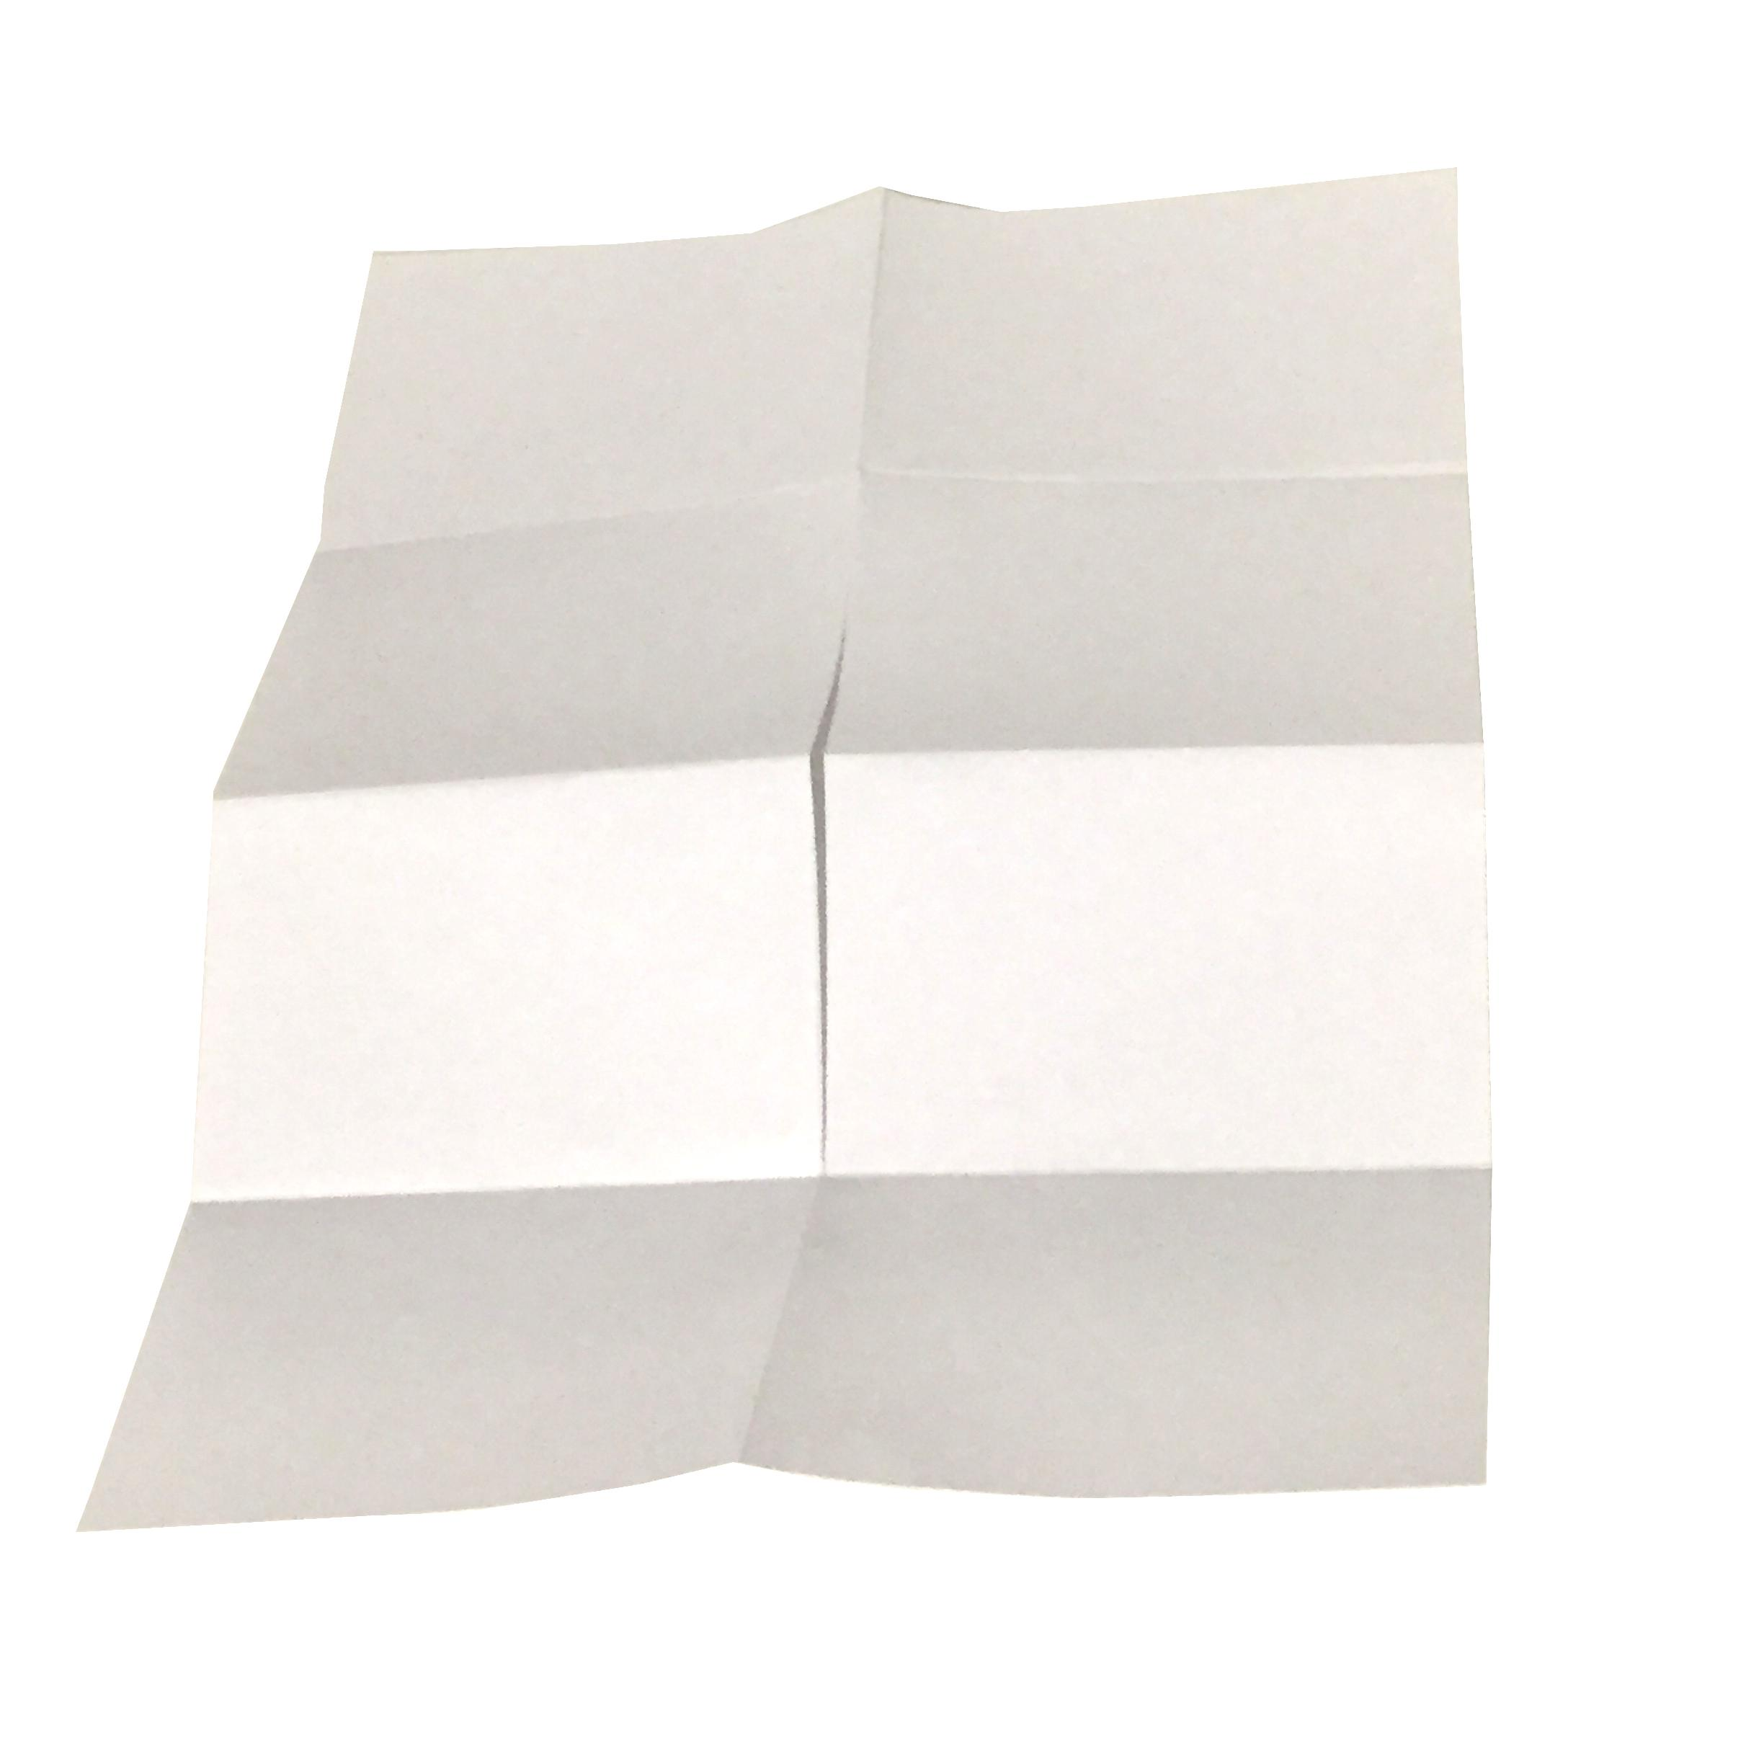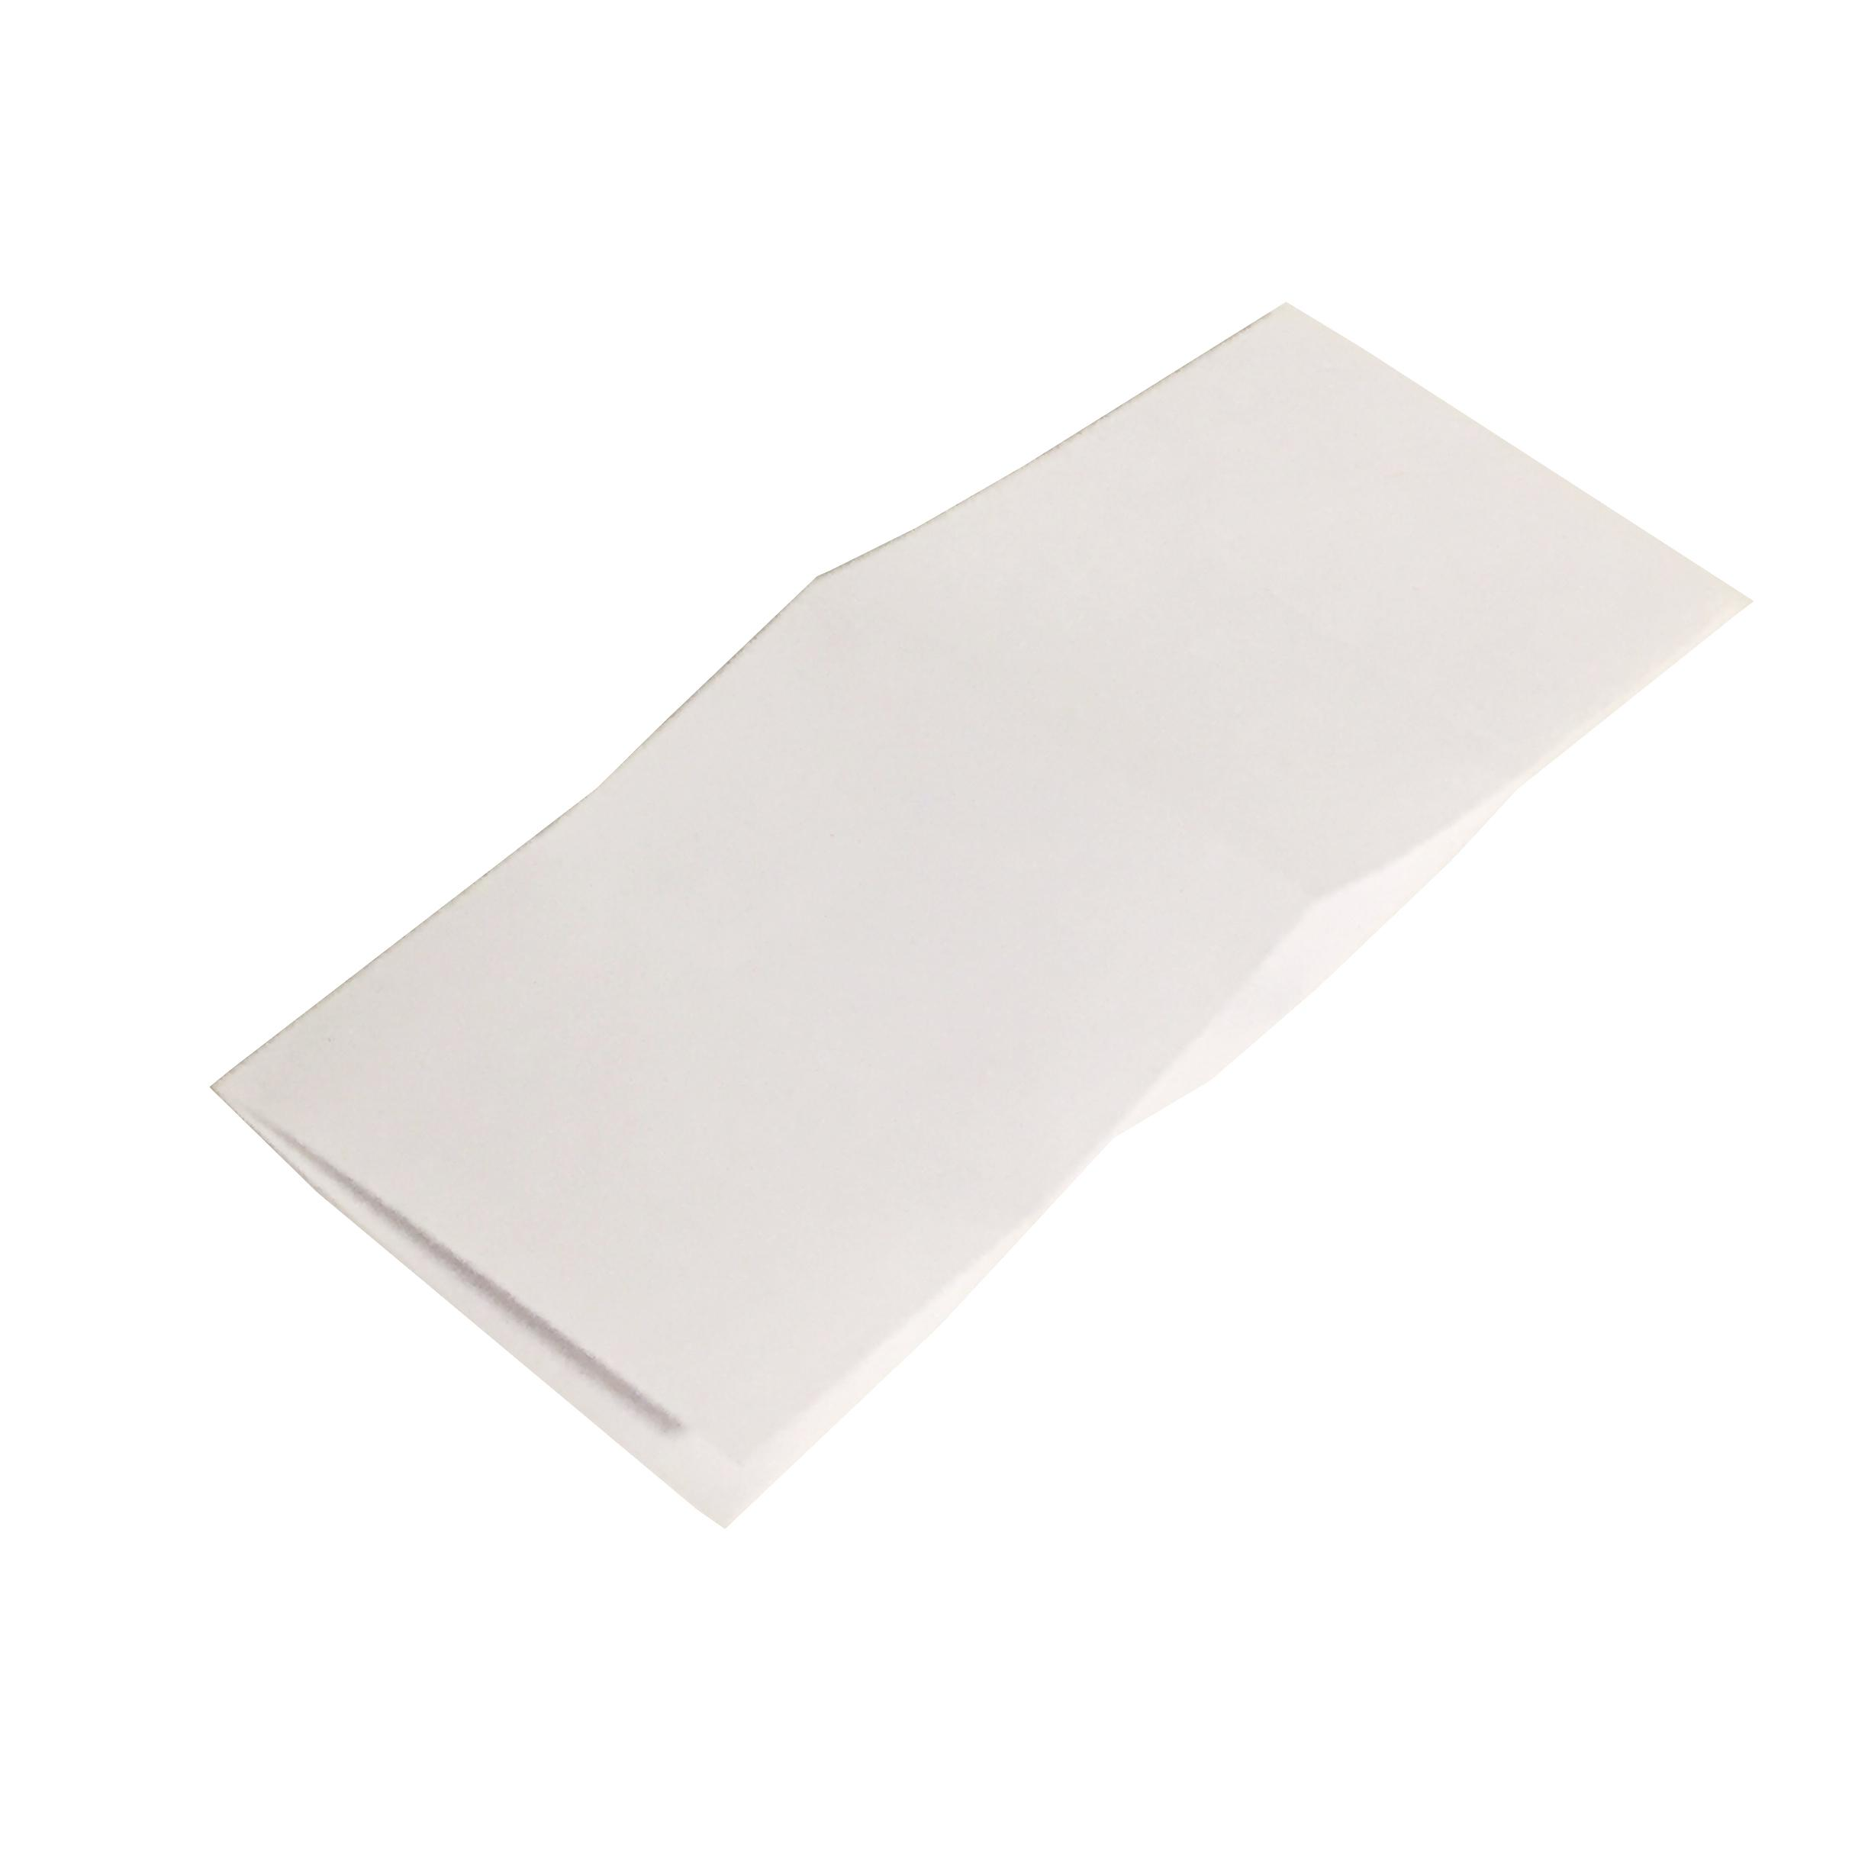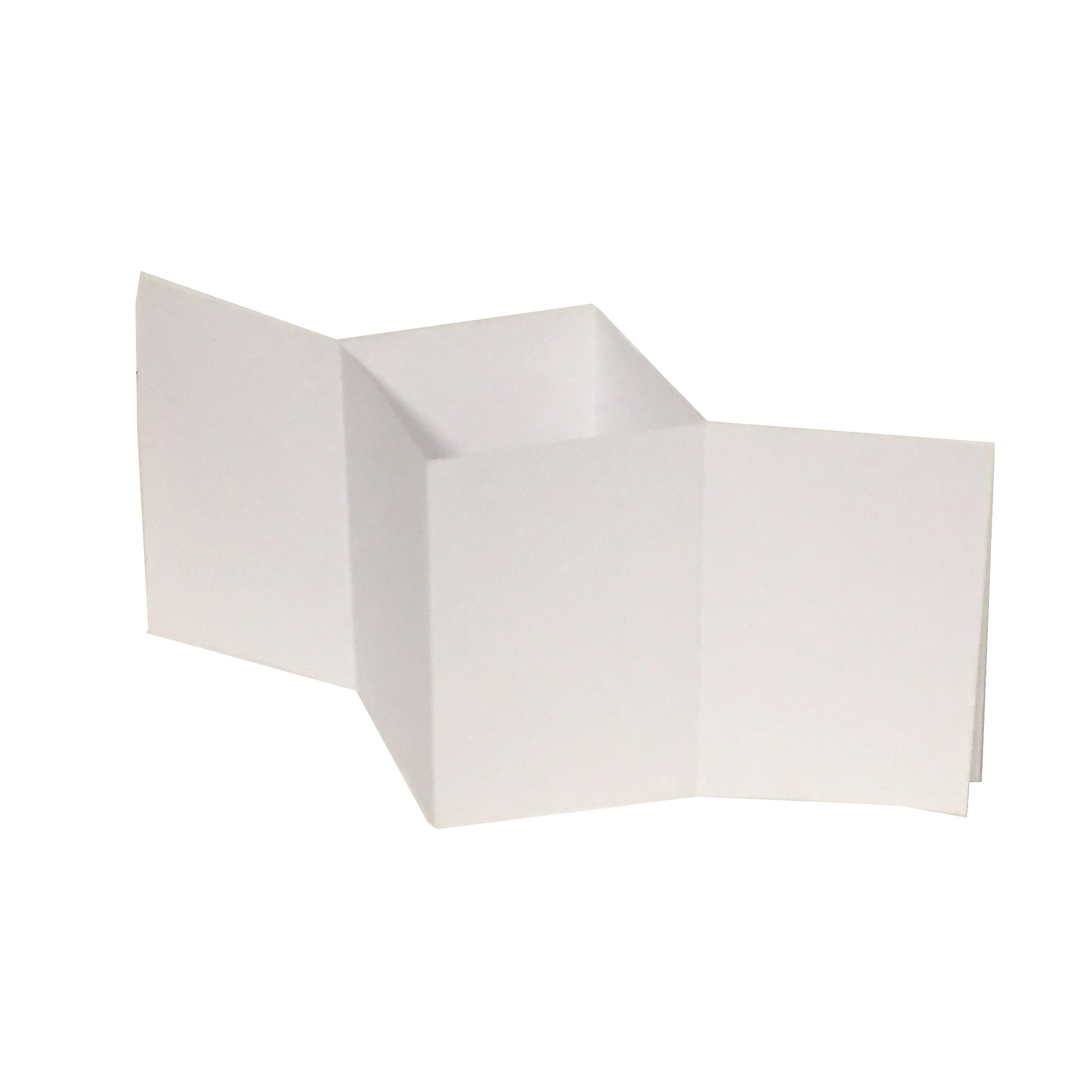

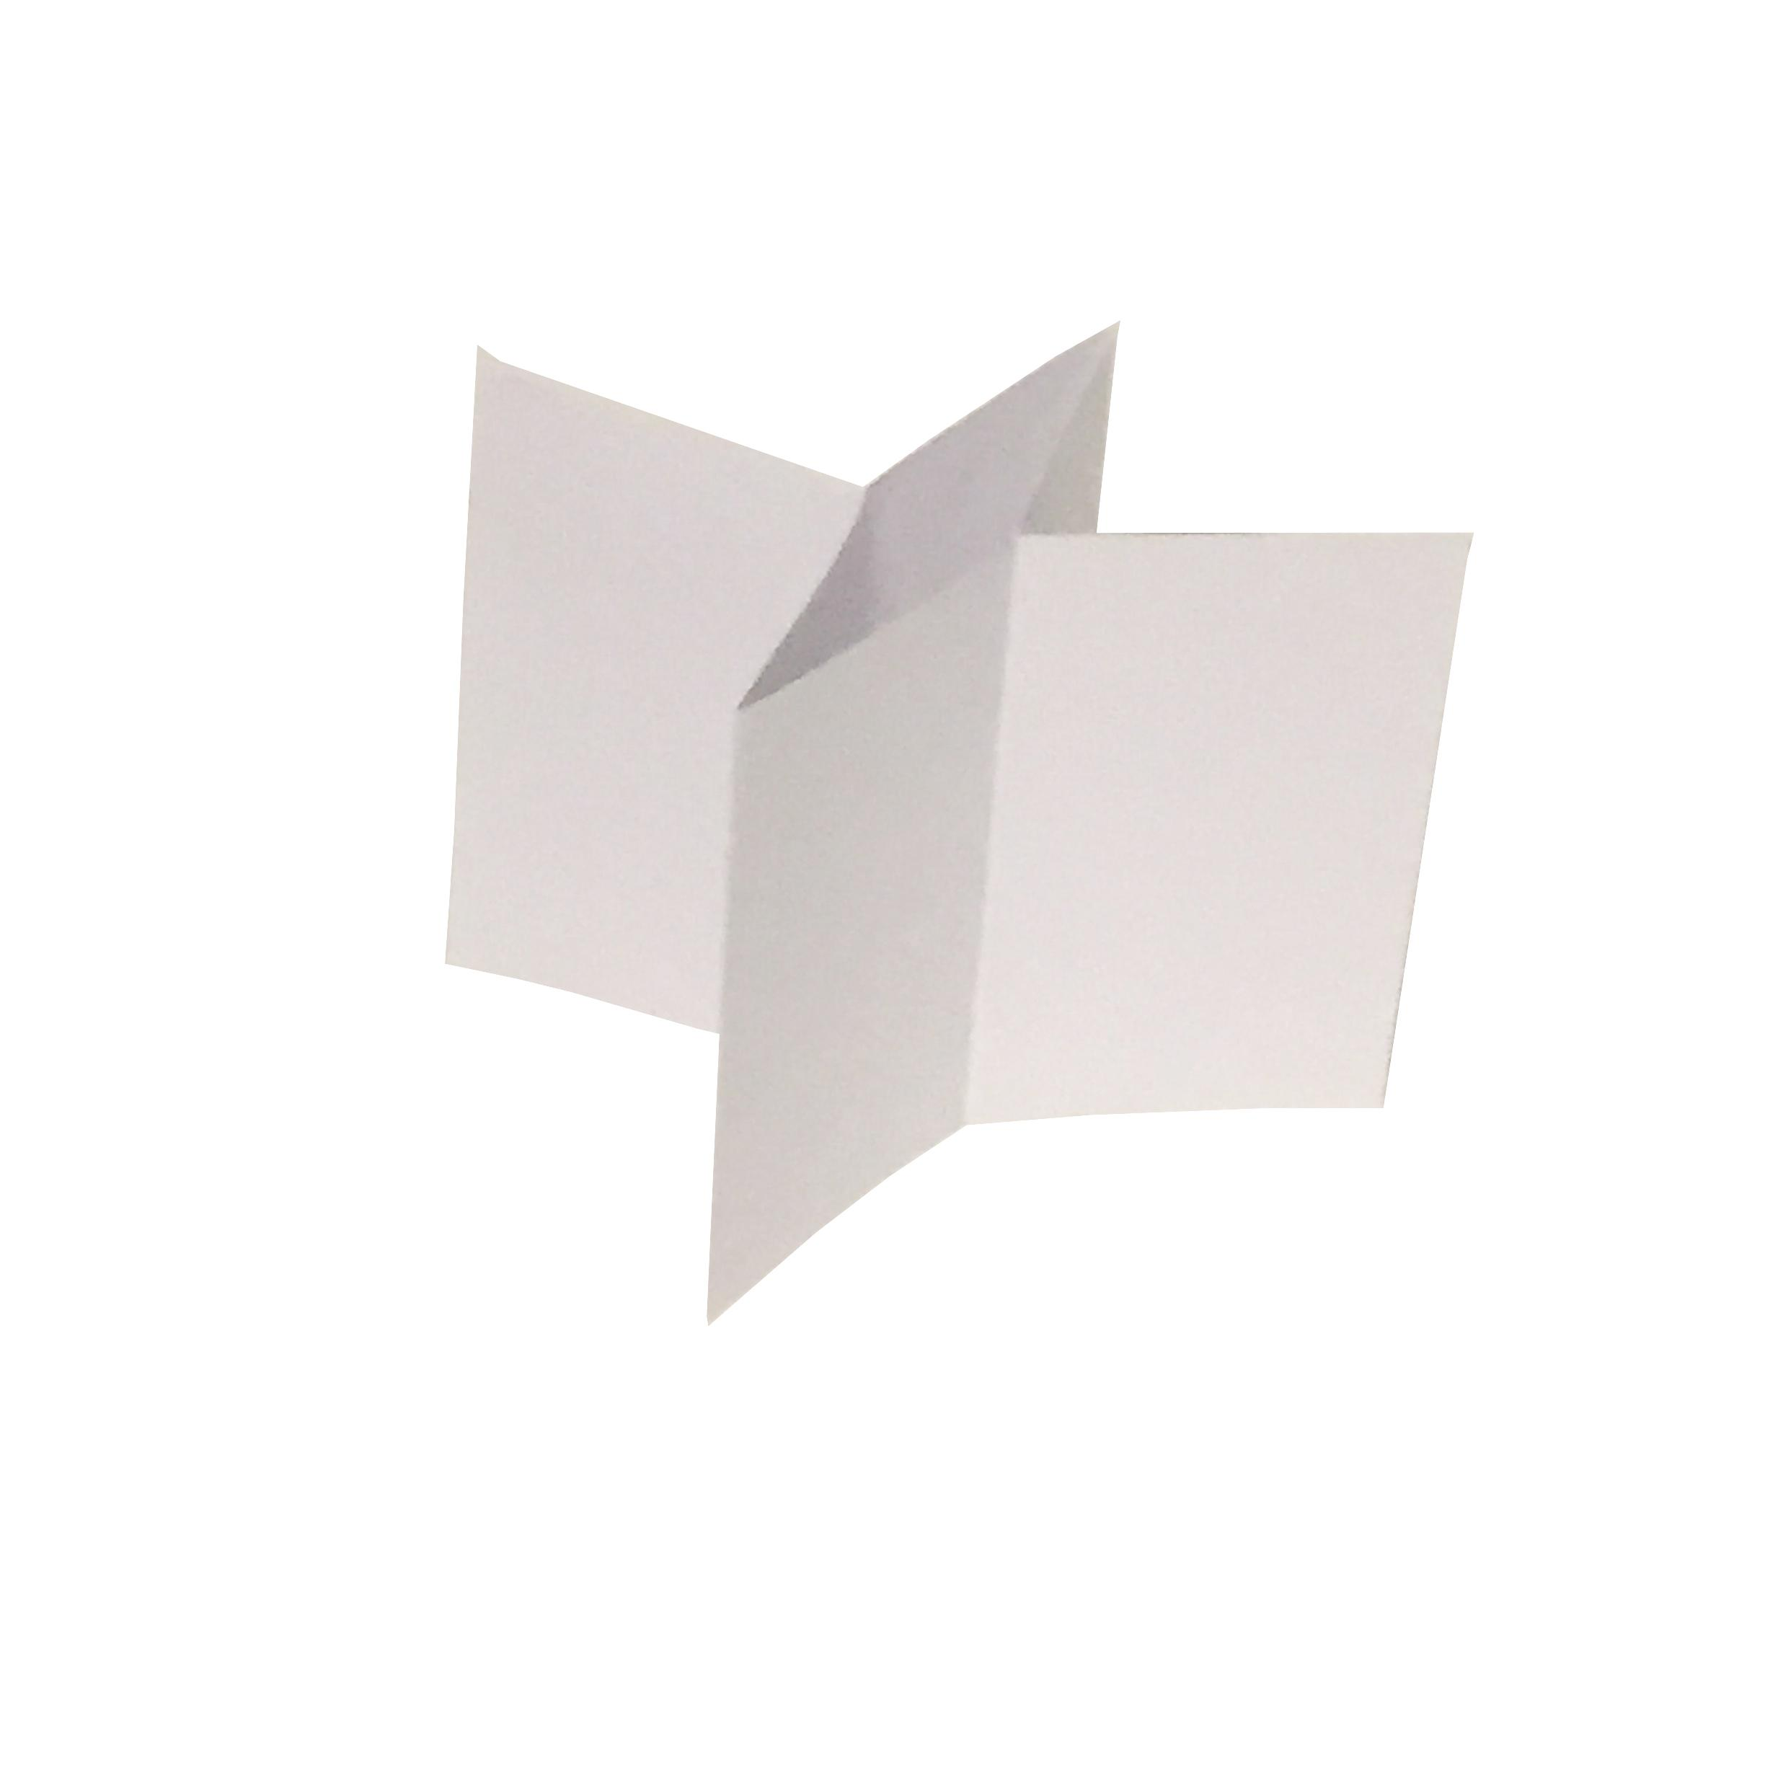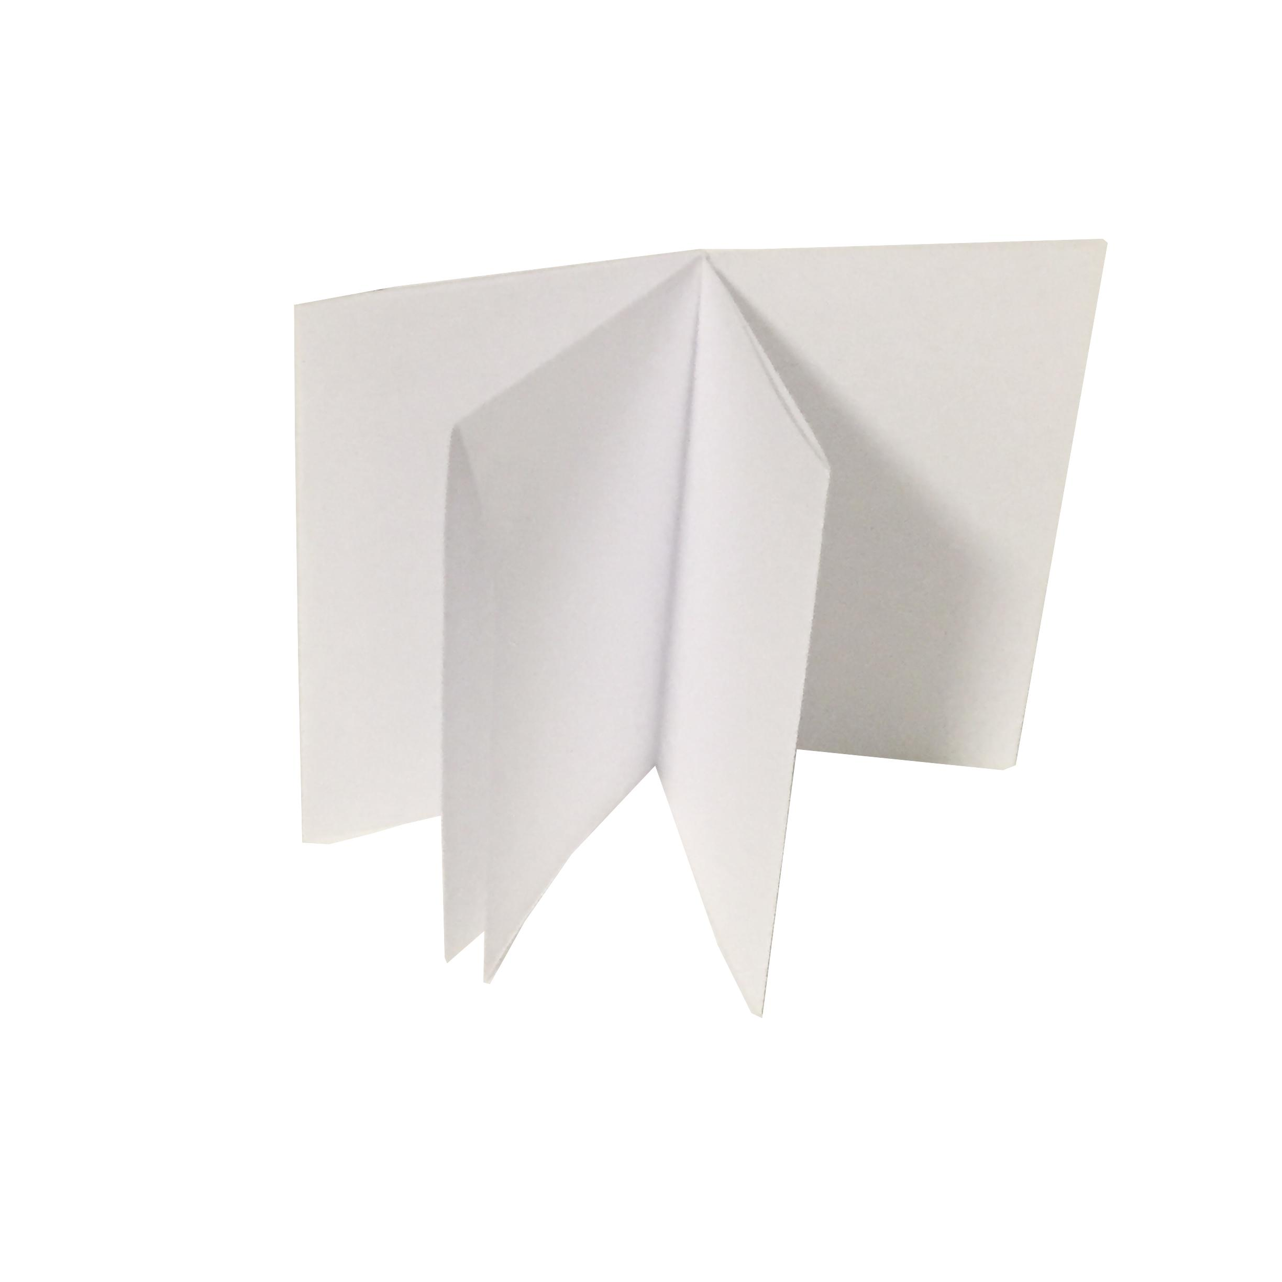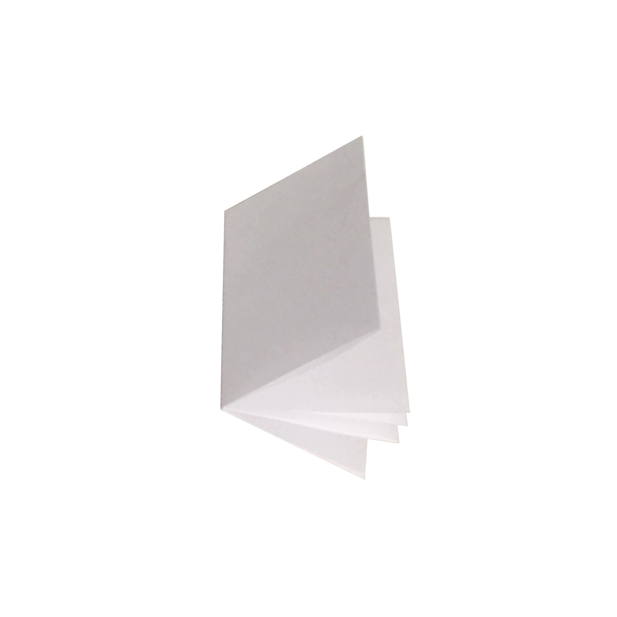

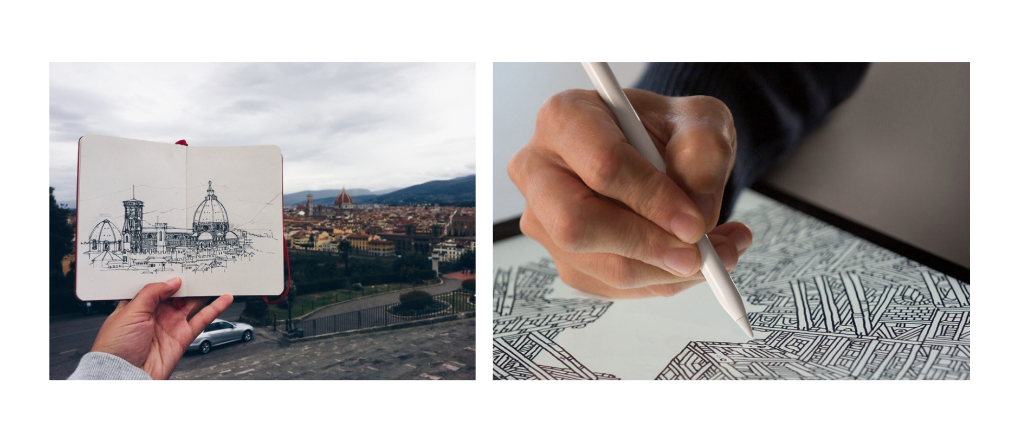

**Description:**

In a time when we can record fleeting moments of inspiration with electronic and smart devices through various applications, what becomes the role of the physical sketchbook? Is there a unique need or function for a small portable, paper-based platform to be on us as often as our smart phones or mobile devices? What kinds of personal explorations or qualitative information does the speed and materiality of the physical sketchbook form allow us in a way that smart or digital devices may not?

Although fields like interaction design use the term Lofi and Hifi to talk about prototypes, this workshop pulls those terms directly from the the world of music. Lofi aesthetics are based on the sonic imperfections that happen during the audio recording process, usually considered undesirable effects by the engineers. Yet, some of our most favorite musicians embrace the lofi sounds as a way to further express themselves. These once perceived imperfections becomes a stylistic choice that’s responsible for songs we love.

When we choose to use a digital tablet versus a physical sketchbook, we can sometimes fall into the use of the undo button or reaching a certain level of polish through erasing past history. However some of the more beautiful things and stylistic evolution happens when exploring with that element of chance for mistakes. This ability to show us these things over time is a real benefit to the materiality of a physical sketchbook. We may see stylistic elements or themes begin to surface that we may not have noticed otherwise. So although we may have access to the high fidelity ways of making, sometimes it’s the low fidelity ones that help us better understand our process.

The term wi-Fi was chosen as a pun off the words high fidelity (hi-fi). Just like there are benefits to low fidelity as a creative approach (and often financial necessity). Sometimes there are benefits to being your own wireless fidelity, using your sketchbook as a way to connect to the world around you with your ears and eyes and a pen, pencil, brush to paper. Although our phone cameras (and all cameras) can be amazing tools as well, sometimes we forget to go back and reflect on the image we took to understand what it was that captivated us in that moment. When you chose to draw or write about it instead, you are processing the information in trying to include and translate what it was about that moment that struck you.

In this 1 hour workshop we’ll create 2 diy book formats: The 1 page zine as a quick method to have something on the go to use as sketchbook, but also as a self-publishing platform. And then the Accordion/ Concertina fold as a way to see your thought/sketch evolution in a continuous unfolding line.

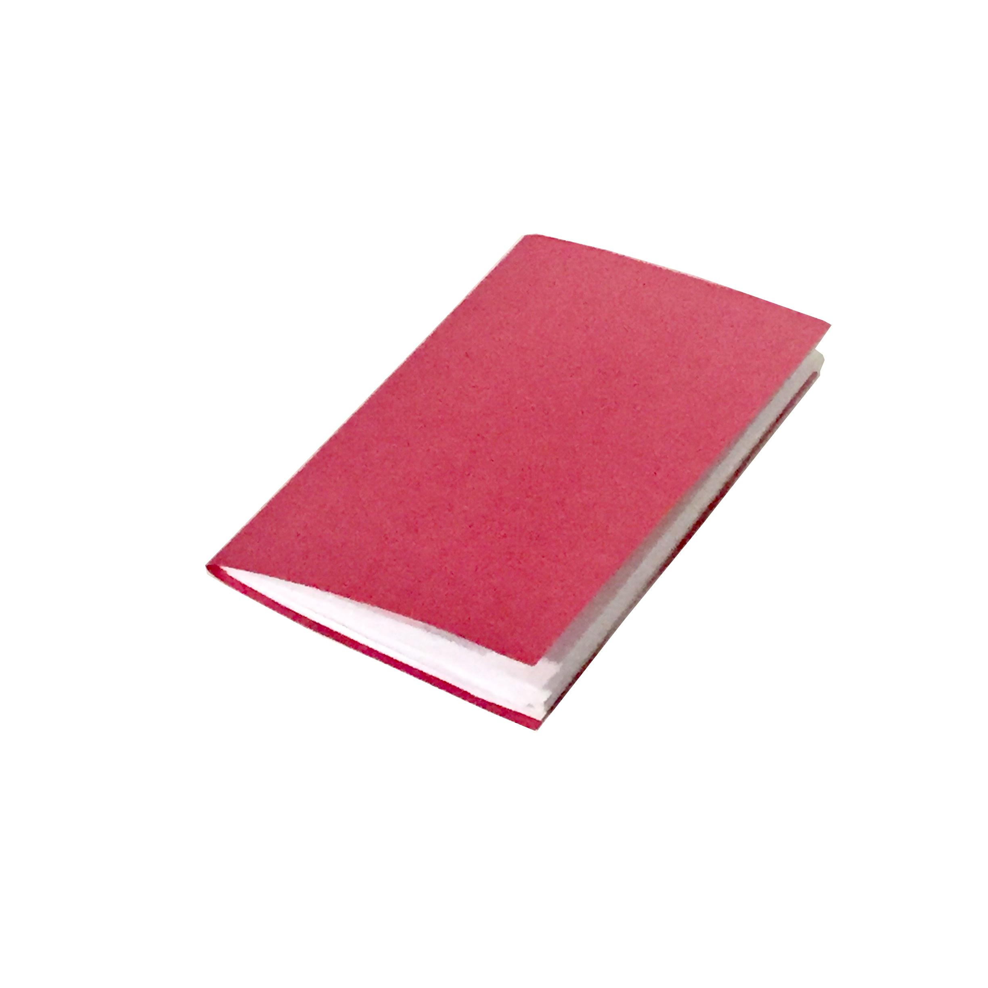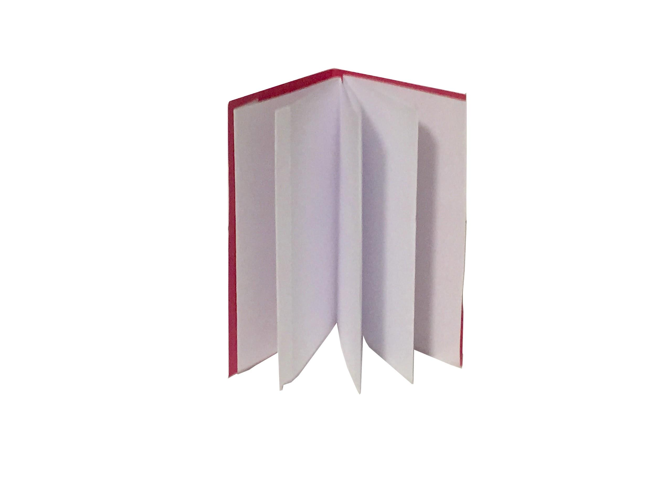

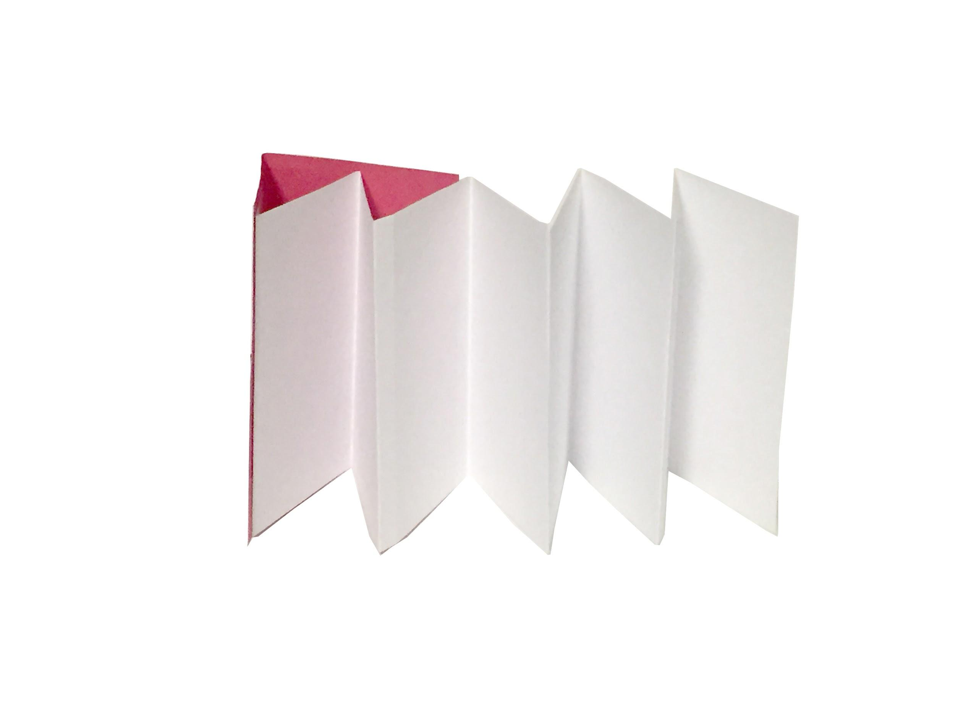

**Learning objective:**

* Through making a 1 page zine booklet and a simple accordion/concertina fold sketchbook, we’ll reflect on the benefits of maintaining a physical sketchbook during the digital age as a tool for exploring and processing our own ideas and the world around us.

**Outcome/Tangible Takeaways:**

* A case for diy sketchbooks as a tool in addition to our smartphones, tablets and DSLRS
* 2 book forms and their affordances
  + 1 Page Zine Fold Format
  + Accordion Fold Format
* Follow-up email with
  + additional resources
  + Treasure map of places in NYC for sketchbook making inspiration
  + PDF walk-throughs of both formats
* *Brief overview of sketchbooking in history [add on from feedback in next iteration** ]*

**Syllabus / Workshop structure:**

* **Slideshow (10 min)**
  + Lofi / hifi presentation
  + Introduce hotdog / hamburger folds [or whichever method you prefer to use to help address folding across the width vs the length of your piece of paper)
* **Book 1: 1-page Zine book (15 min)**
  + Fold book
  + Pass around & talk about brought in examples
* **Book 2: Accordion fold Book (15 min)** 
  + Fold Book
  + Pass around & talk about brought in examples
* **Give a Sketchbook Prompt / Decorate Covers (10 min)**
  + Can choose one that you came up with?
  + We used:
    - “Draw or Write about 3 things from your favorite “Season””
      * Could be:
        + Weather season
        + Food “Seasoning”
        + TV Season
        + Any other Season that Speaks to you
* **Cleanup (10 min)** 
  + can check to make sure you have email address of anyone that came off list that would like to also receive followup email / resources

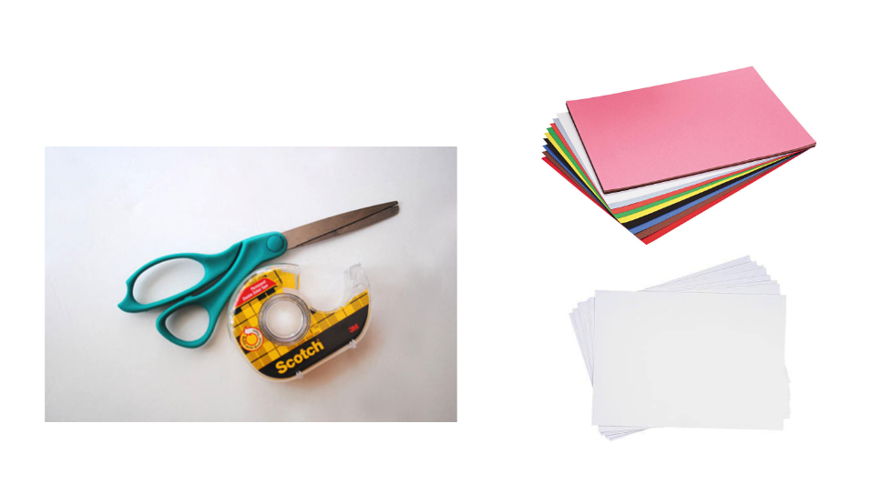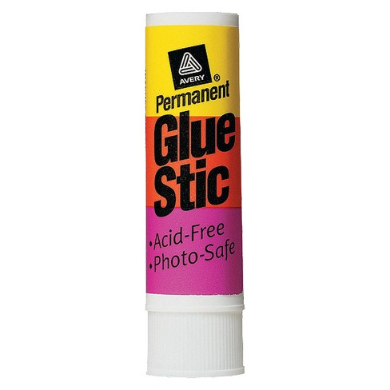

**Material List**

* 8.5” x 11” printer paper [enough sheets for participants to make both formats + errors]
* Assortment of color construction paper
* Double sided tape
* Gluesticks
* Scissors (enough for group to share, ideally 1 per person
* Examples of books that inspire you*~
* Ideally at least 1 of each form:
  + Accordion (aka: Concertina / Leporello)
  + 1 page zine booklet (folds only / non-stapled if possible)

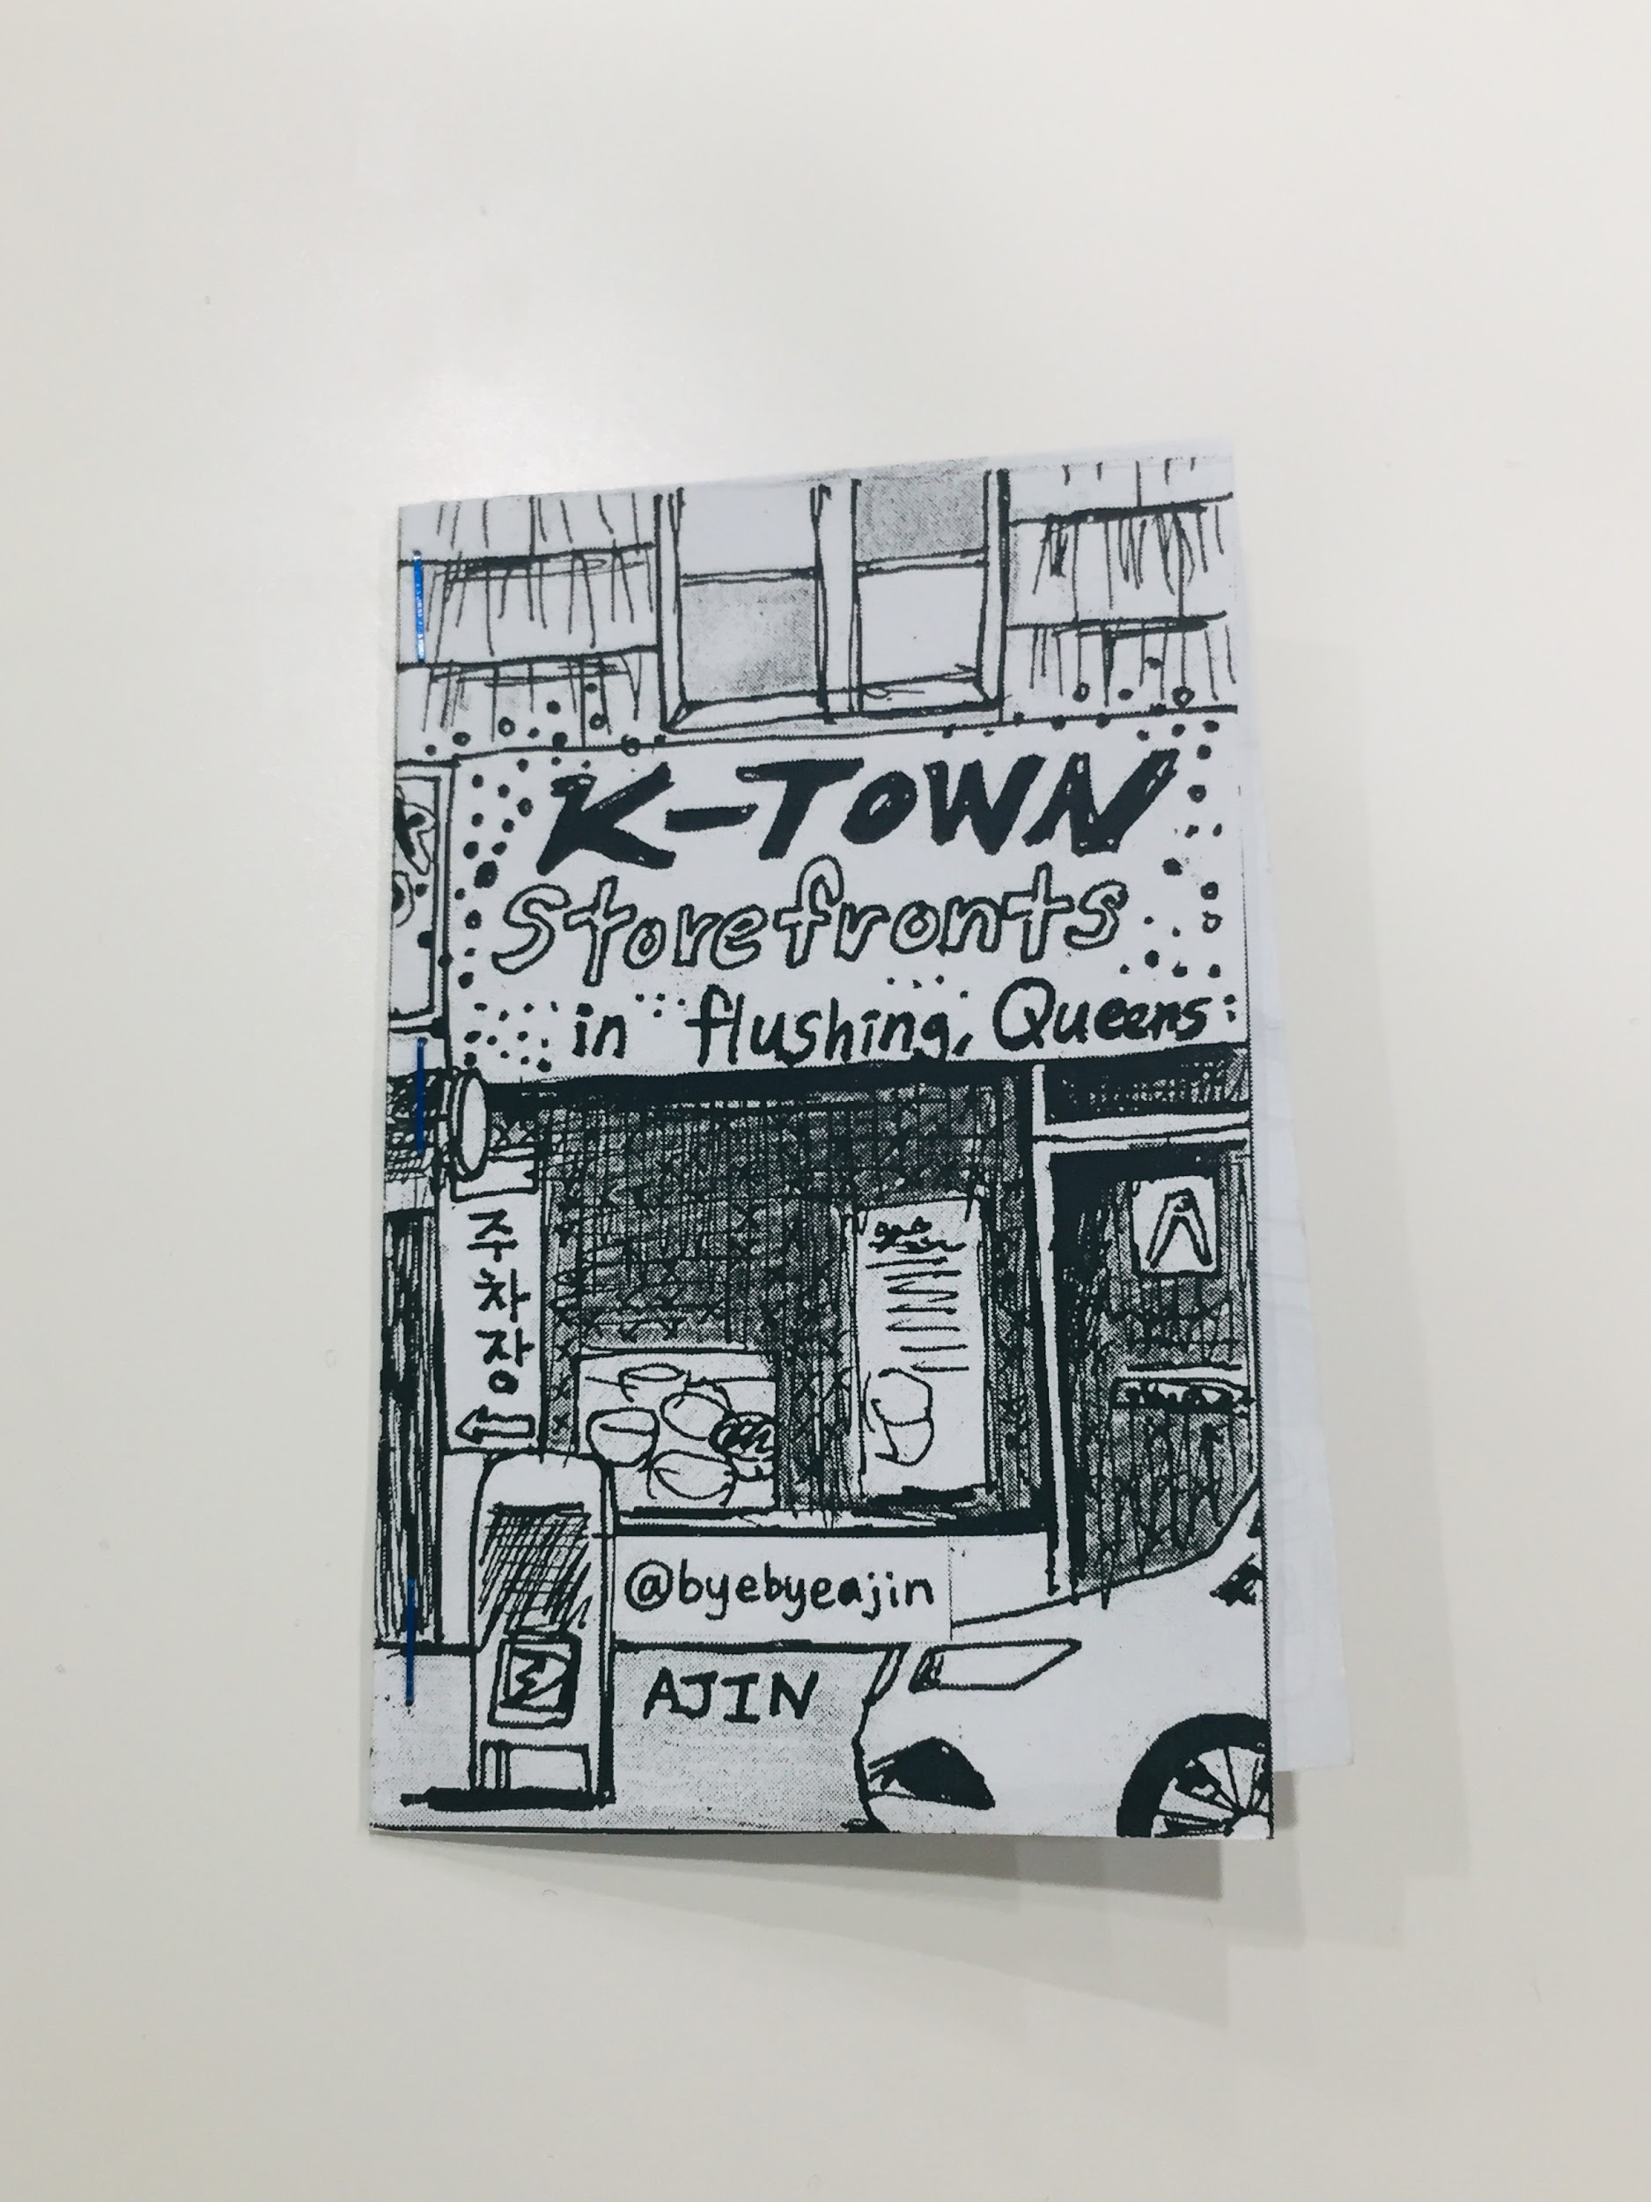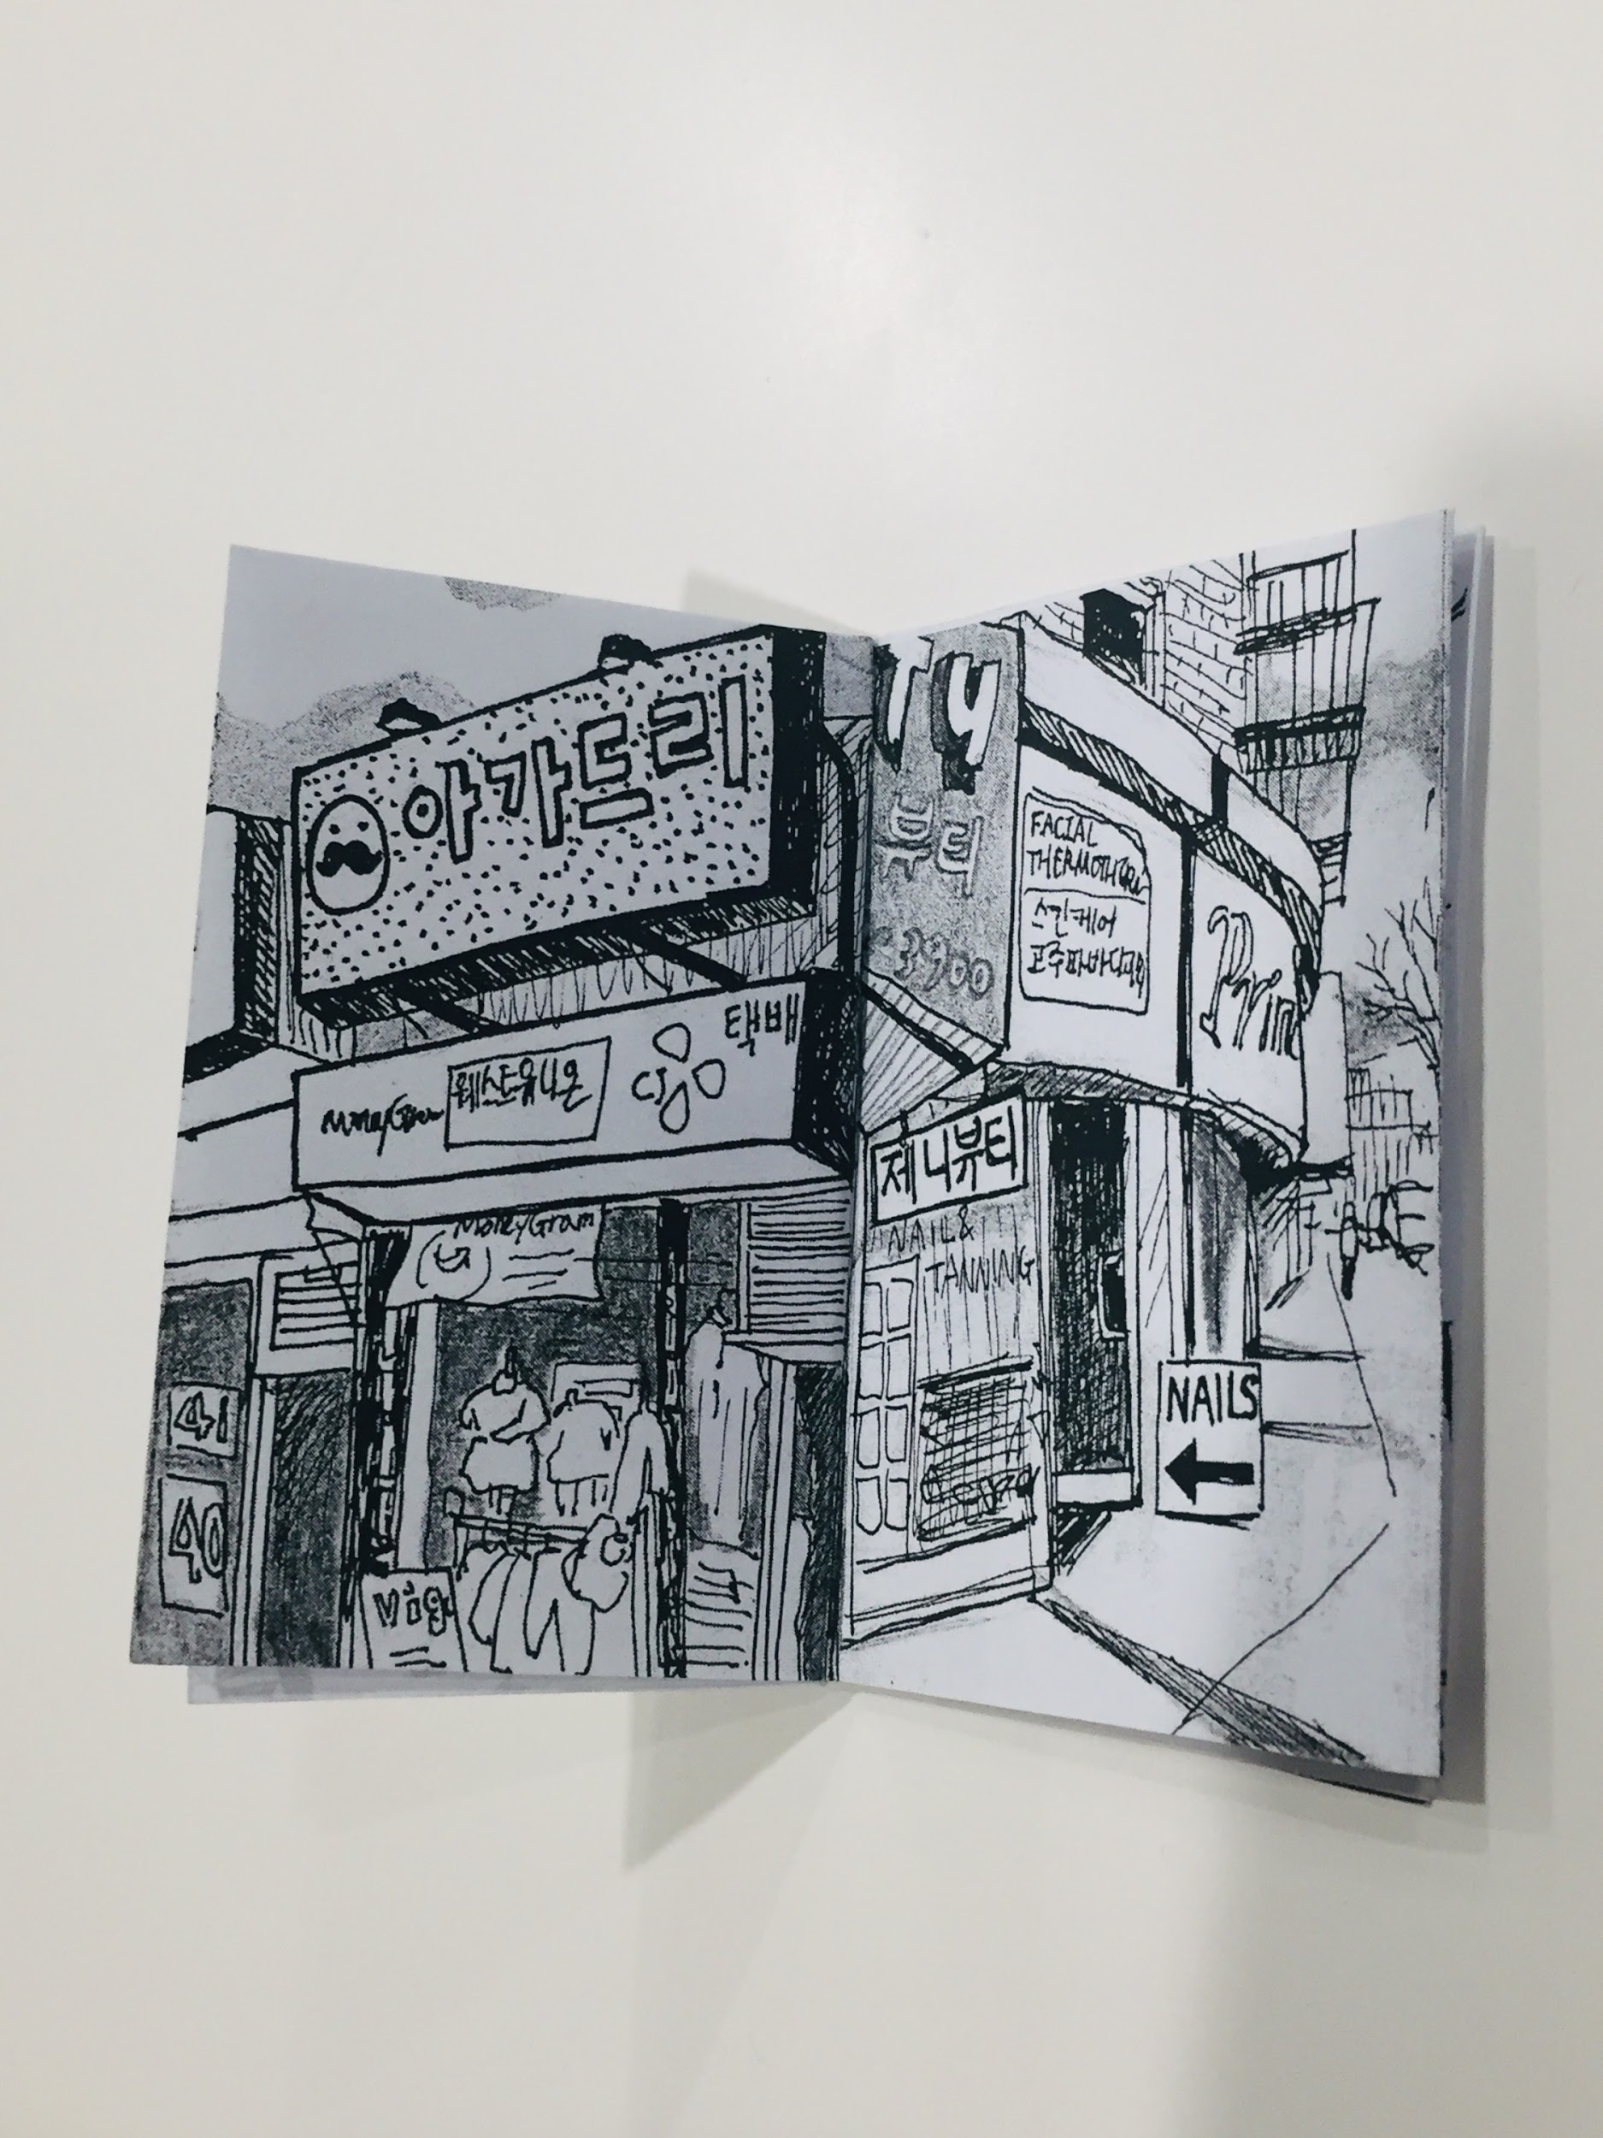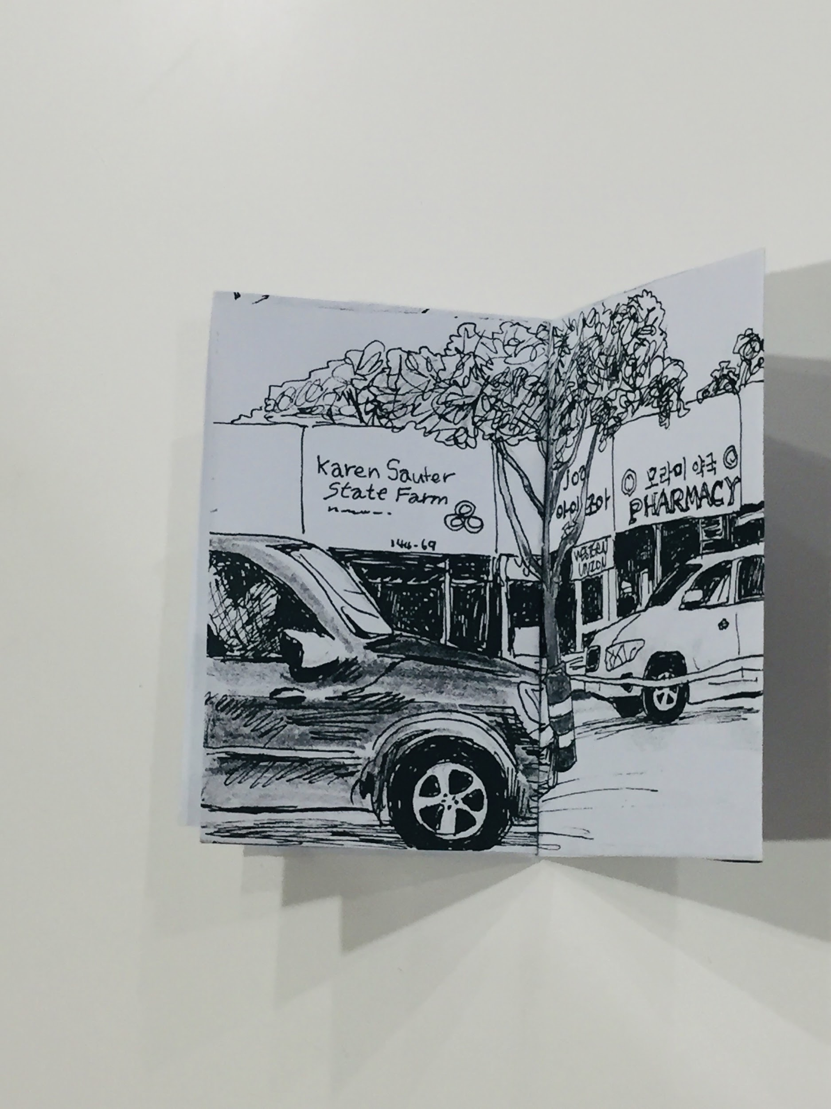

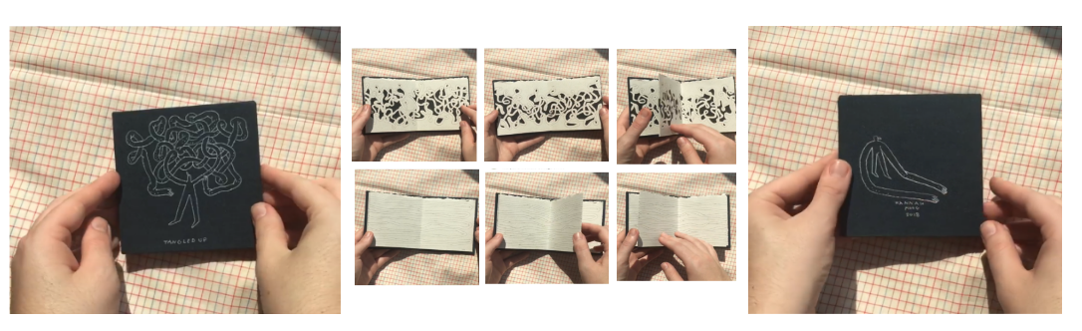

**top: K-town Storefronts in Flushing, Queens //** 1 page zine by Ajin Lim @byebyeajin

**bottom:**  **Tangled Up** // Accordion by Hannah Moog @h_moog

**Budget**

|  |  |  |
| --- | --- | --- |
| **Supply** | **Source** | **Cost** |
| 8.5 x 11” paper  (1 ream) | Staples | $7.29 |
| Thicker paper for folded Cover like Construction paper  Ex: Blick Construction Paper / Acid-free | [Art Supply Store](https://www.dickblick.com/products/blick-construction-paper/?clickTracking=true&wmcp=pla&wmcid=items&wmckw=11409-1003&gclid=CjwKCAiAwojkBRBbEiwAeRcJZPiKApiZoDEGrrlgWOuxf03aJGvqrvH74eybl9Mb_gij83pjXdcAhxoC_gsQAvD_BwE)  Or Staples | $2.17 |
| Scotch Double Sided Tape, 1/2" x 7 yds. (pack of 3)  x2 | [Staples](https://www.staples.com/Scotch-Double-Sided-Tape-1-2-x-250-1-Core-3-pack-3136/product_649280) | $6.49 |
| Pencils Staples Mechanical Pencils, No. 2 Medium Lead, Dozen | [Staples](https://www.staples.com/Staples-No-2-Gripped-Mechanical-Pencils-Medium-0-7mm-Assorted-Colors-12-pk-29082/product_2071562) | $5.19 |
| Scissors | Bring from home / School  [adjust cost if need more pairs] | Free |
| GlueSticks (4 pack) | [Staples](https://www.staples.com/Elmer-s-All-Purpose-School-Glue-Sticks-Clear-Washable-4-Pack/product_600859?cid=PS:GooglePLAs:600859&ci_src=17588969&ci_sku=600859&KPID=600859&gclid=CjwKCAiAwojkBRBbEiwAeRcJZKusfyrIpMfb6I1yI0Ry814FRPQCaQyeWrQ-Kyq6ubS-VDM4FpVLOhoCDJAQAvD_BwE) | $4.29 |
| Bone Folder (or folding alternative ex: handle of scissors or dull butterknife) | Bring from home  *bone folder is to show as an example tool but attendees can use the back of their fingernail or scissor handles | Free* |
| Paper for clean work area  Could use Butchers Paper or large piece of recycled cardboard? | TBD / we used for free from ITP | TBD |
| Total Cost of Supplies [not including tax] | | $25.43 |
| *max budget is $50.00, could use remainder towards providing more chapbook or zine, book examples to pass around? Or bring some from your own or friends’ collections. Or if you would like to buy different kinds of paper too, like coverweight sheets verses construction paper. | | |

Timeline**

Will adjust over longer timeline for final draft (more room for promotion to different communities, workshop test runs + feedback fold in, and prepping the followup beforehand so it's ready for sendout the evening/day after workshop )

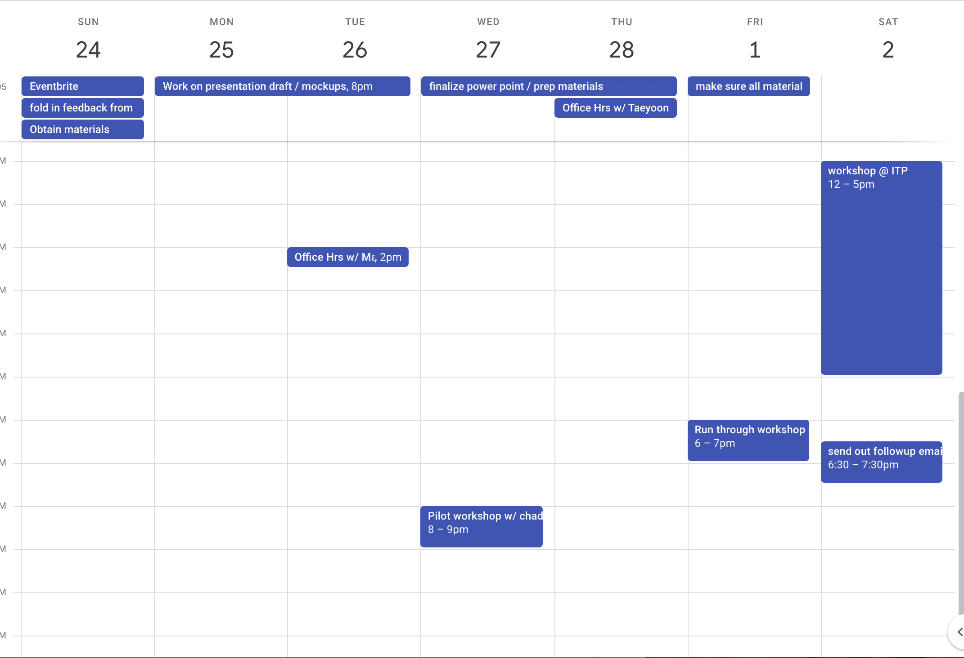

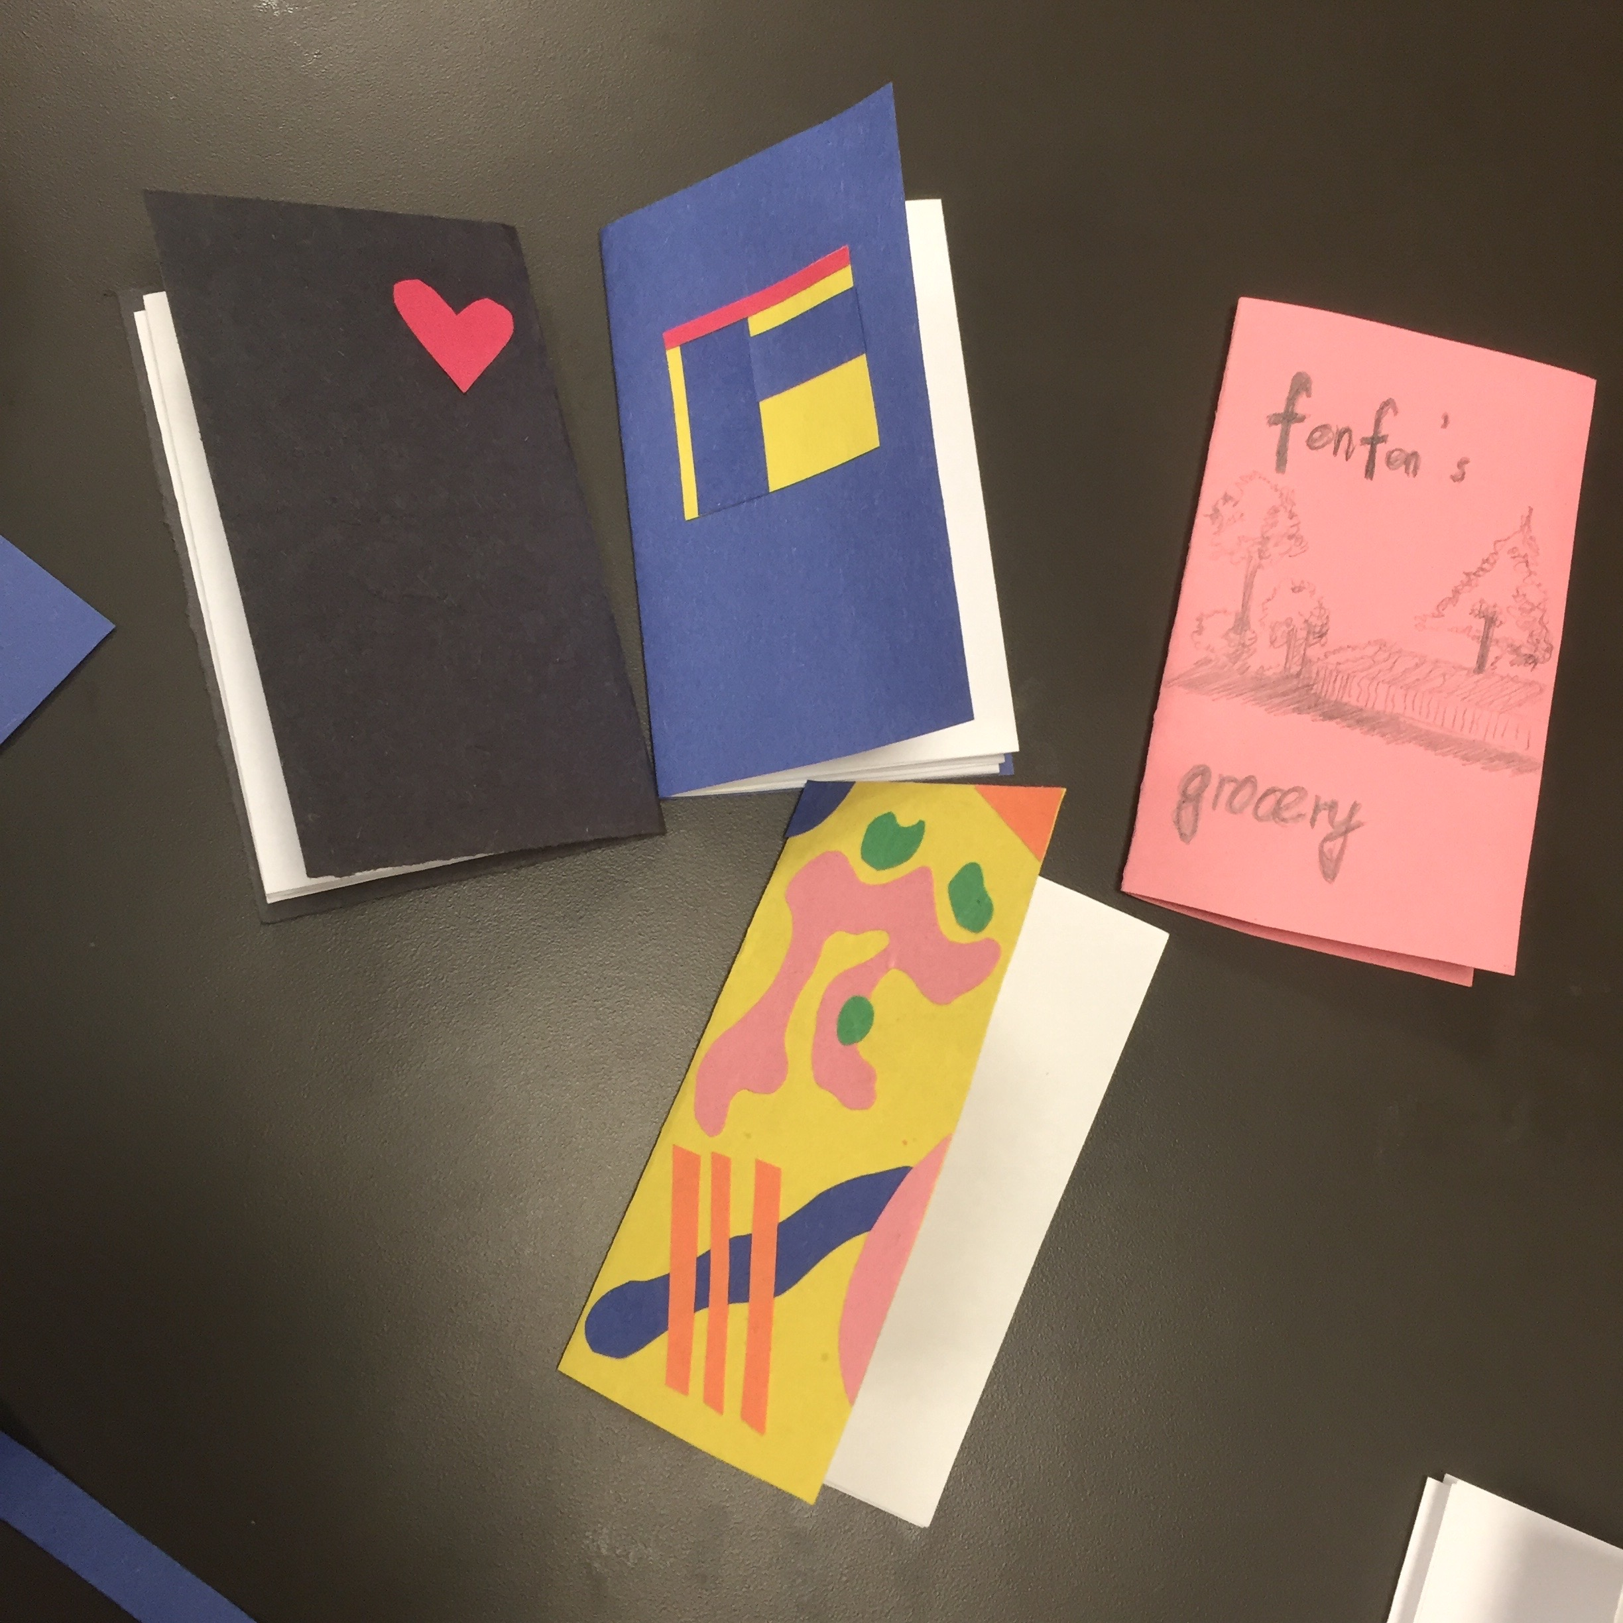A 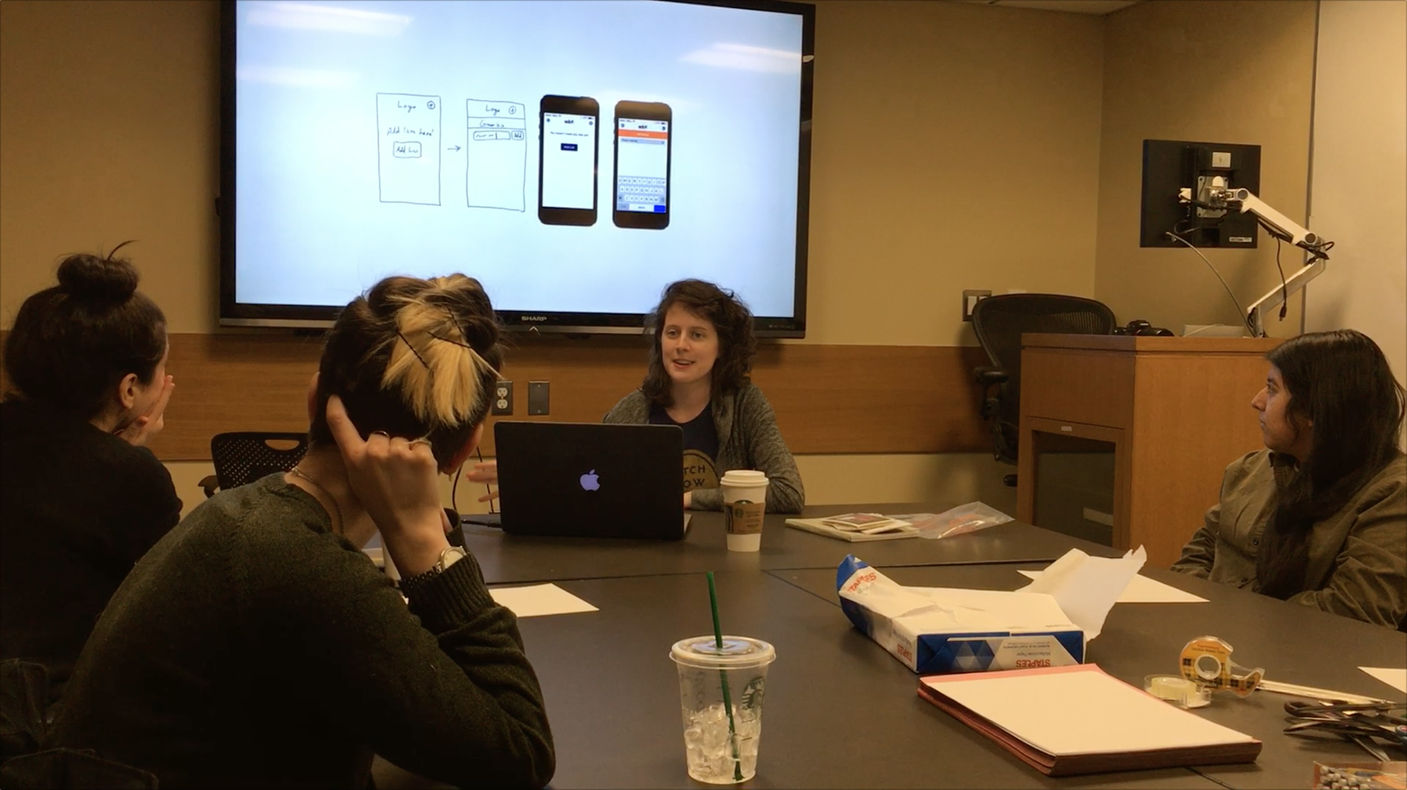B 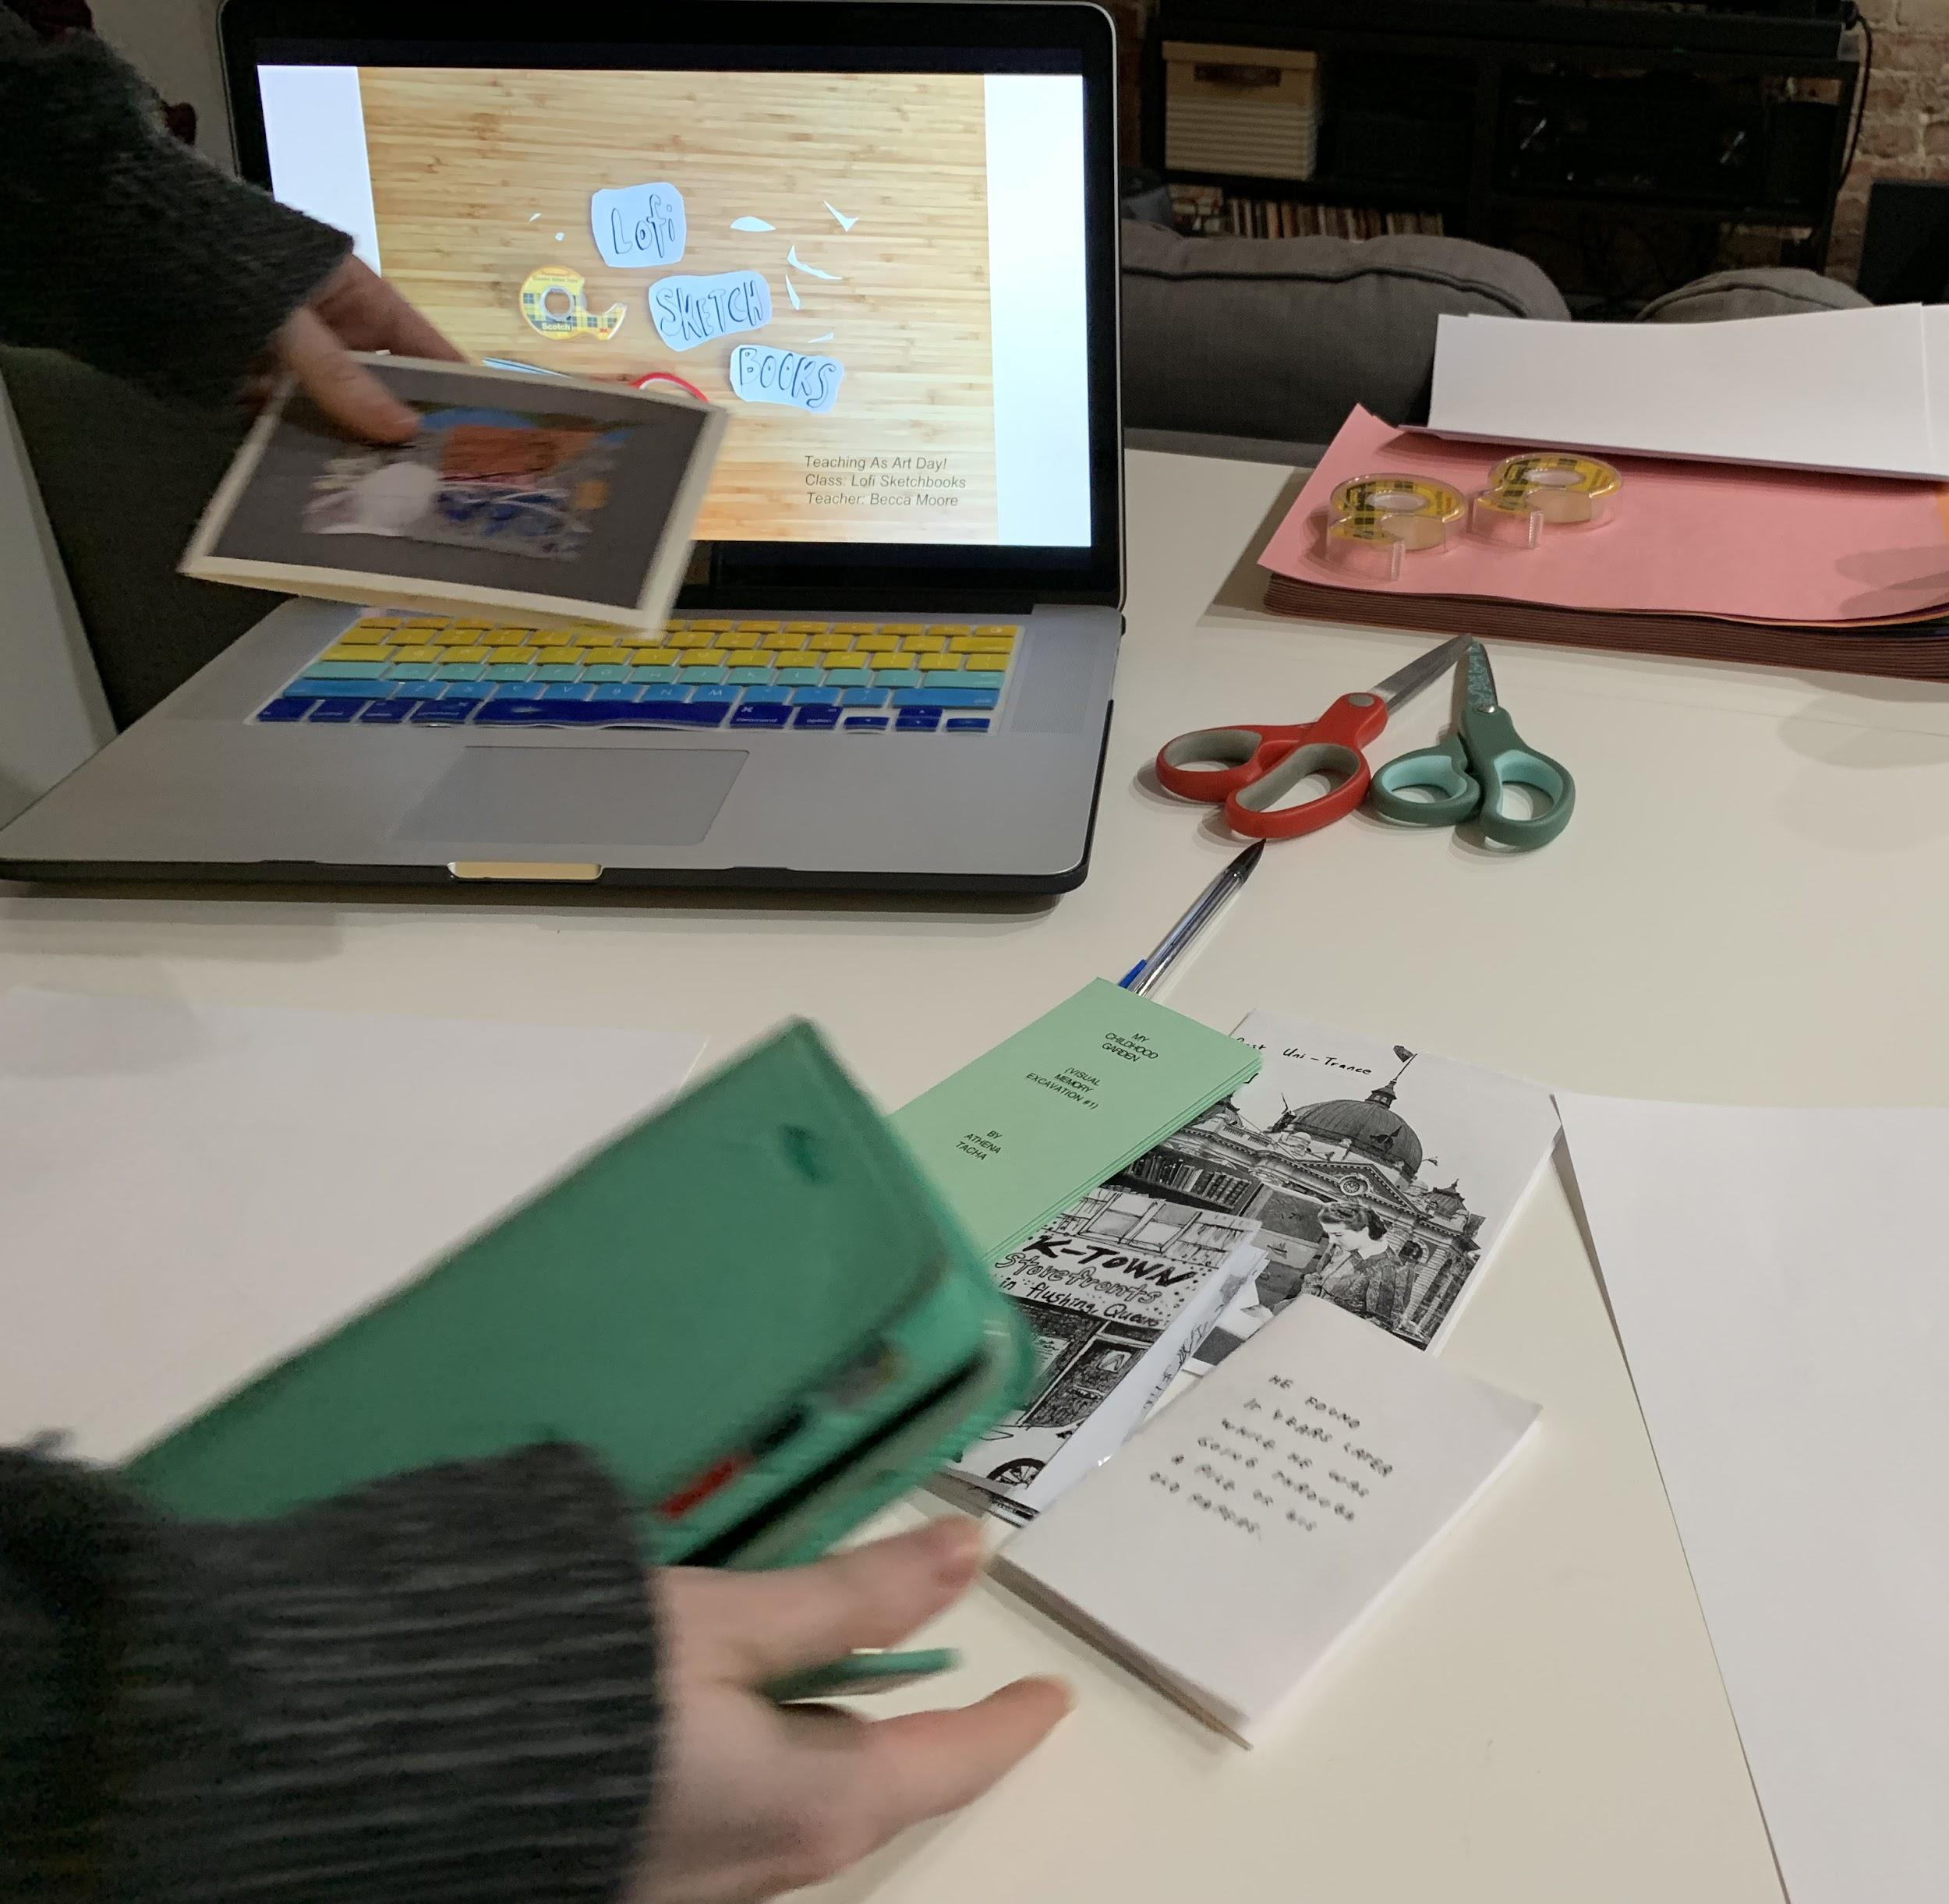C

1. Collection of participant-made accordion folds with decorated covers
2. Talking through the idea of lofi as a tool & creative process/approach across different fields
3. Prepping for 2nd workshop test-run

Follow up Email:

Make sure after the workshop to send a follow-up thank you email to participants. Could include:

* *A pdf walk through of each book type (ideally made in your own personal style)*
* *Additional bookmaking links based on ones that participants expressed interest in*
* *Link to slides*
* *Links to projects of interest or if there’s another sort of next step bookmaking workshop in the community like this free one at* [*Printed Matter St. Marks*](https://www.printedmatter.org/programs/events/799)
* *A treasure map of places for more bookmaking inspiration*
* *A couple extra prompts to help people break past the fear of a blank page*

[Here](https://docs.google.com/document/d/10TVjhkV6ZtcWlzG9-8AWE5F-NuCiZLbrYXHMbP-TMYY/edit) is resource pdf sent out after the March 2nd Workshop also included below:

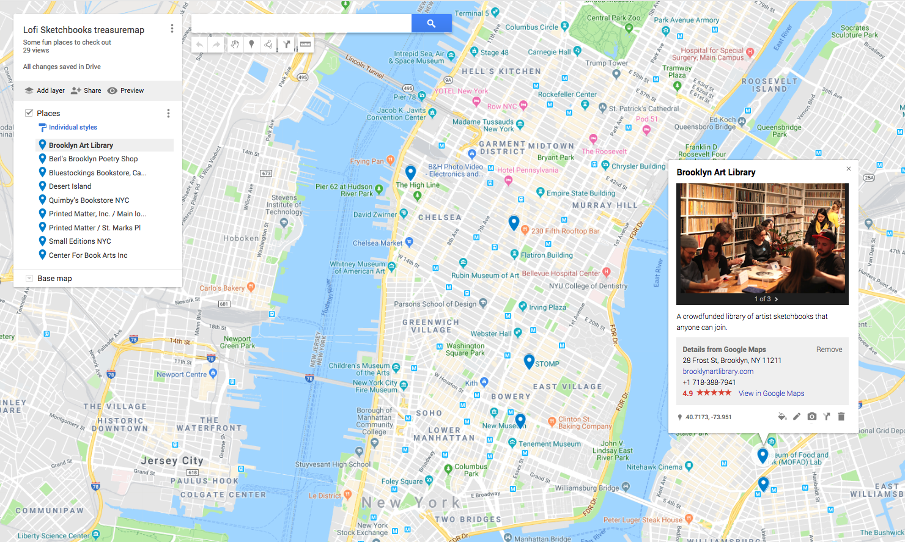

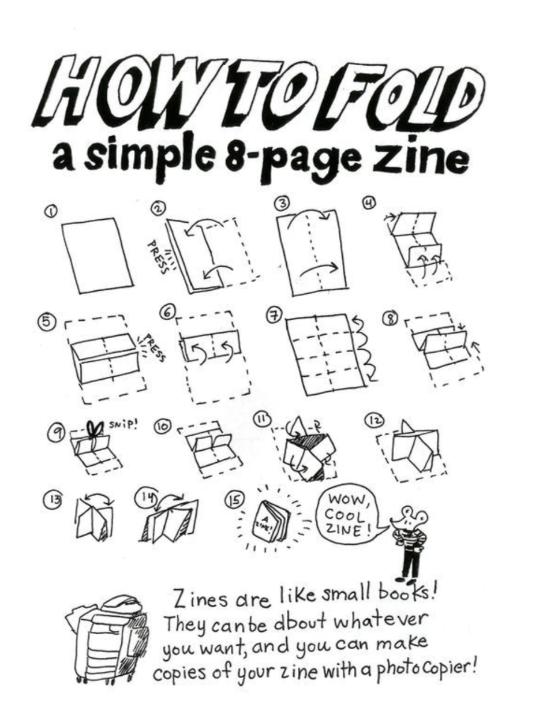

This handout tutorial is from a Zine Workshop run by Portland-Based cartoonist [Liz Yerby](http://www.lizyerby.com/) at the [Portland Children’s Museum](https://www.portlandcm.org/)

(pg1)

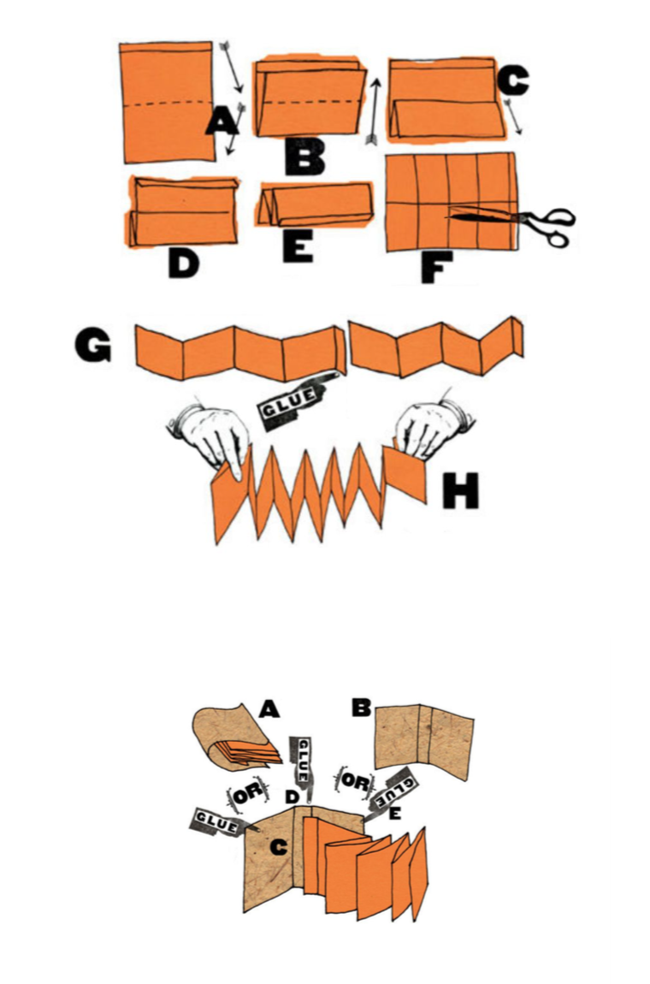

Accordion Fold tutorial & images above are adapted from [**How to Make Books: Fold, cut & Stitch your way to a One-of-a-kind book**](https://www.penguinrandomhouse.com/books/169001/how-to-make-books-by-esther-k-smith/9780307353368/) **by Esther K Smith of** [**Purgatory Pie Press**](http://purgatorypiepress.com/)

**1st image set** = creating the Accordion fold pages for inside sketchbook

**2nd image set** = using an adhesive (double sided tape or glue), secure your sketchbook pages inside your cover

**Accordion folds are also known as Concertina & leporello

(pg2)

**\*~Resources~\***

**Some Books & Helpful Sites**

# [Slides from presentation](https://docs.google.com/presentation/d/1pFYqq-yOh4IP1_teSpcztjlq_o8z2NatwMf80XWN0BI/edit?usp=sharing)

# [*How to Make Books: Fold, Cut & Stitch Your Way to a One-of-a-Kind Book*](https://www.amazon.com/How-Make-Books-One-Kind/dp/0307353362/ref=sr_1_1?crid=1TYMVKRYJUXPZ&keywords=how+to+make+books&qid=1551590028&s=books&sprefix=how+to+make+books%2Cstripbooks%2C128&sr=1-1)

* [*Bound: 15 beautiful bookbinding projects*](https://www.amazon.com/Bound-15-beautiful-bookbinding-projects/dp/0857835076/ref=sr_1_1?keywords=Bound%3A+15+beautiful+bookbinding+projects&qid=1551589885&s=books&sr=1-1-spell)
* [*The Art of the Fold: How to Make Innovative Books and Paper Structures Hardcover*](https://www.amazon.com/Art-Fold-Innovative-Books-Structures/dp/1786272938)

# [Dear Data: The Book & Project site](http://www.dear-data.com/thebook)

* [*Printed Matter: Printing & Binding Glossary*](https://www.printedmatter.org/services/the-bulletin/glossary)
* [*Printed Matter: List of Zine Fairs*](https://www.printedmatter.org/services/the-bulletin/book-and-zine-fairs)

# [*Pocket bookbinding kit - learn to make two sewn bindings,and two bonus folded mini books*](https://www.etsy.com/listing/545424975/pocket-bookbinding-kit-learn-to-make-two?ga_order=most_relevant&ga_search_type=all&ga_view_type=gallery&ga_search_query=pamphlet+stitch+kit&ref=sr_gallery-1-2&organic_search_click=1)

* [*Bookbinding Kit: Japanese Sewing*](https://www.etsy.com/listing/210275297/bookbinding-kit-japanese-sewing?gpla=1&gao=1&&utm_source=google&utm_medium=cpc&utm_campaign=shopping_us_a-craft_supplies_and_tools-patterns_and_how_to-kits&utm_custom1=7ac90481-31e9-4bf7-91cd-2bb89cd53617&utm_content=go_270947675_41952116376_190744336037_aud-459688892115:pla-297994408538_c__210275297&gclid=Cj0KCQiAn4PkBRCDARIsAGHmH3cZzher9hE9uac-Fsa3G8I2DC02pMJjhVW56i-xraUPvXXaNP9HyZcaAgjLEALw_wcB)

# *Vid:* [*How to make a 1 page Zine : Step by step*](https://www.youtube.com/watch?v=ZG64-mVCuz0)

* *Vid:* [*DIY Watercolor Sketchbooks (Video: Accordion Style/ No Stitching)*](https://www.youtube.com/watch?v=v9ayxvmHCXg)
* *Vid:* [*3 and 5 hole Pamphlet Stitch Tutorial: How to Bind a Journal*](https://www.youtube.com/watch?v=fZh27cE4Dko)  *(for continued sketchbook fun - Pamphlet Stitch)*
* *Vid:* [*Big Bang Data: Dear Data*](https://www.youtube.com/watch?v=iqaVe1MCTlA)

**Some Places //** [**Map**](https://drive.google.com/open?id=18odYB6hCbLemv0LTuXD2mOxdYgThV2KG&usp=sharing)

* [*Brooklyn Art Library*](https://www.brooklynartlibrary.com/)
* [*Berl’s Brooklyn Poetry Shop*](http://www.berlspoetry.com/)
* [*Blue Stockings*](http://bluestockings.com/)
* [*Desert Island Comics*](http://desertislandcomics.tumblr.com/) *&* [*Quimby’s Bookstore*](https://quimbysnyc.com/)
* [*Printed Matter, Inc.*](https://www.printedmatter.org/)
* [*Small Editions NYC*](http://www.smalleditionsnyc.com/)
* [*Center for Book Arts NYC*](https://centerforbookarts.org/)
* [*Zines at the New York Public Library*](https://www.nypl.org/about/divisions/general-research-division/periodicals-room/zines)

**Projects Mentioned in Slideshow**

* [Mailbox 2: by National Monument Press [publishing project by Zach Clark]](http://nationalmonumentpress.com/mailbox-2)
* [K-Town Storefronts in Flushing Queens Zine](https://www.printedmatter.org/catalog/51463/)  by Ajin Lim
* [Winter Zine by @marianflorcita](https://www.instagram.com/marianflorcita/)
* [He Found it Years Later by Jason Polan](https://www.printedmatter.org/catalog/51708)
* [@rinnosaurusrex extended doodle / pattern exploration accordion](https://www.instagram.com/p/BTpTwn5Fb-i/?utm_source=ig_share_sheet&igshid=jkckq295t6c)
* [My Childhood Garden (Visual Memory Excavation #1) by Athena Tacha](https://www.printedmatter.org/catalog/tables/418/14350) // [part of her book series](https://www.printedmatter.org/catalog)
* [Claudia Gutiérrez Marfull // Untitled - Graffiti embroidered Accordion](https://www.printedmatter.org/catalog/51733)
* [In Nannycatch Beck // Simon Cutts & Kate Van Houten](http://coracle.ie/in-nannycatch-beck/) // example of illustrating items found in nature along a certain hike
* [Other Scales of Prosody by Tanaz Modabber](http://www.lespressesdureel.com/EN/ouvrage.php?id=6564&menu=)
* Post Uni-Trance [5] by poesveryattractivecousin.wordpress.com [“A list of things I love”]

(pg3)

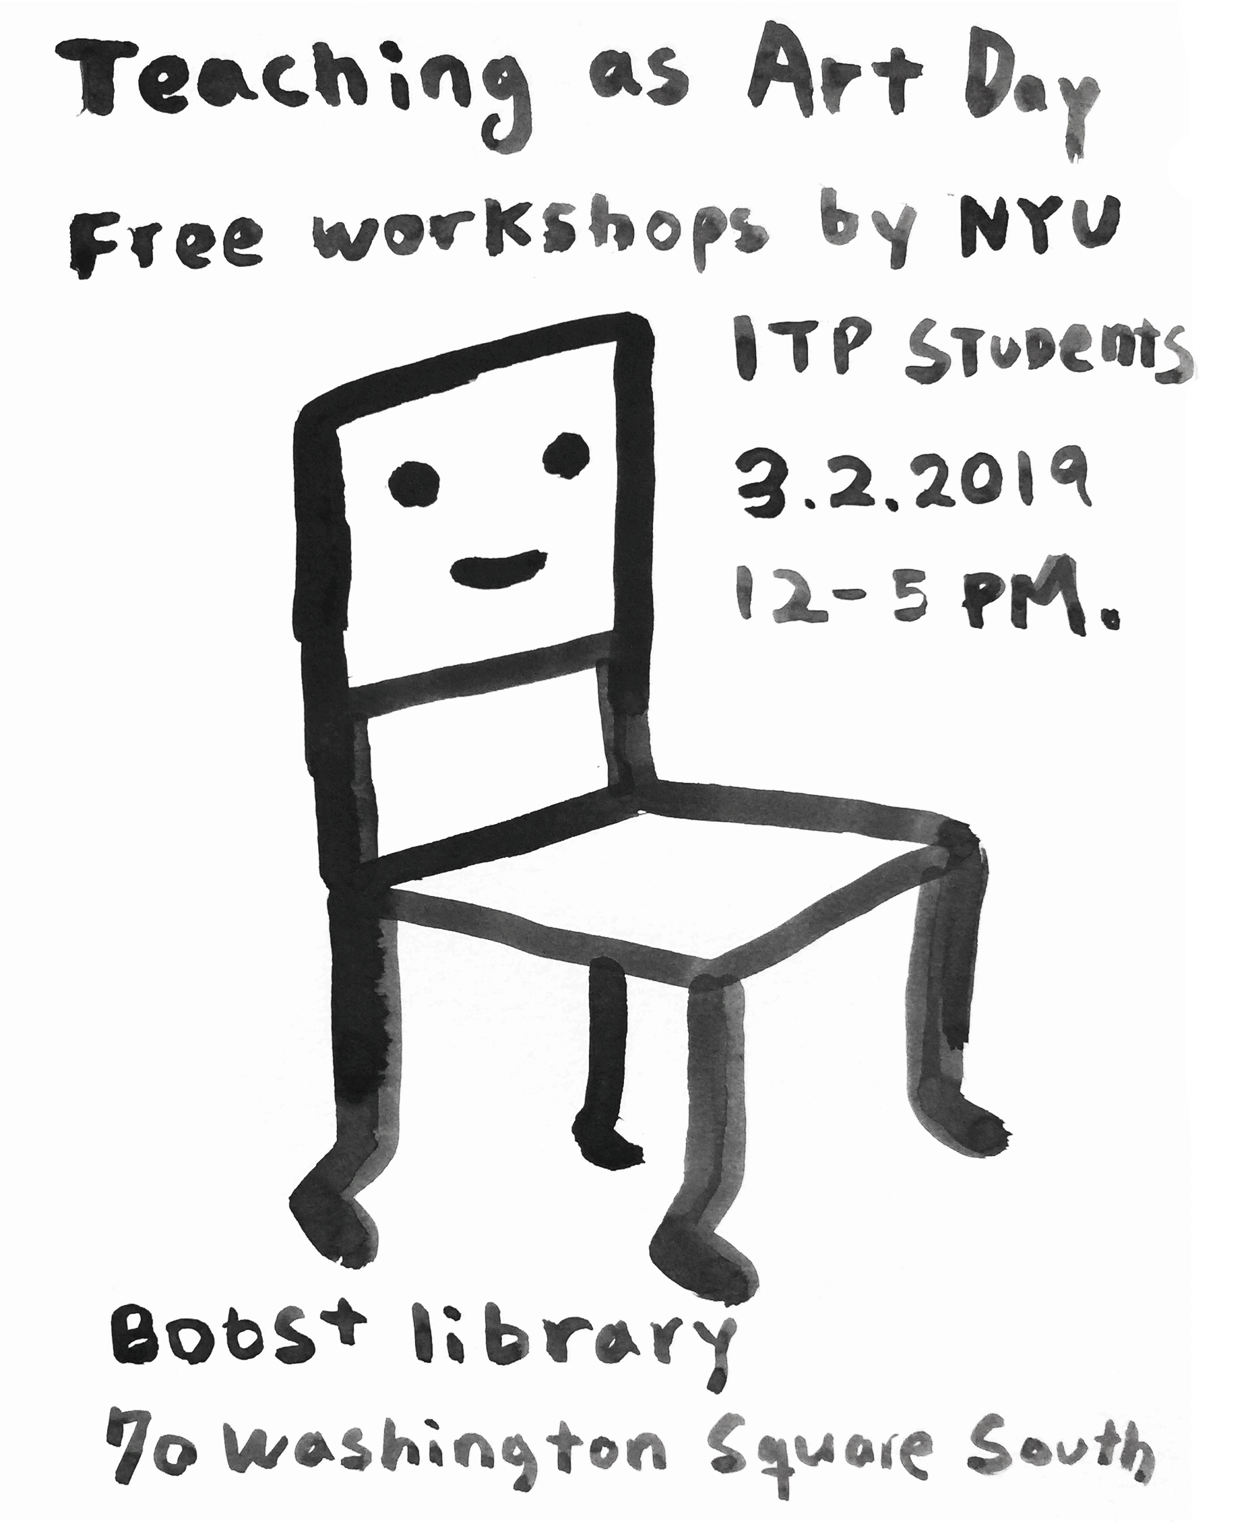

*Lofi Sketchbooks was a workshop presented as a final project for the class Teaching as Art taught by professor Taeyoon Choi at NYU’s ITP graduate program. Read more about the class, event and other workshops \**[*here*](https://teachingasart.github.io/posts/teachingasartday/)*\*.*

*Teacher Bio: Becca Moore is an artist, researcher and facilitator currently studying at NYU's ITP graduate program. Before coming to NYC she was involved in a range of arts, community, music and film projects. She loves to make things especially with and alongside others.*

*Instagram:* [*@beccadmoore*](https://www.instagram.com/beccadmoore/)

*ITP Student Blog:* [*https://30km-s.blog/*](https://30km-s.blog/)

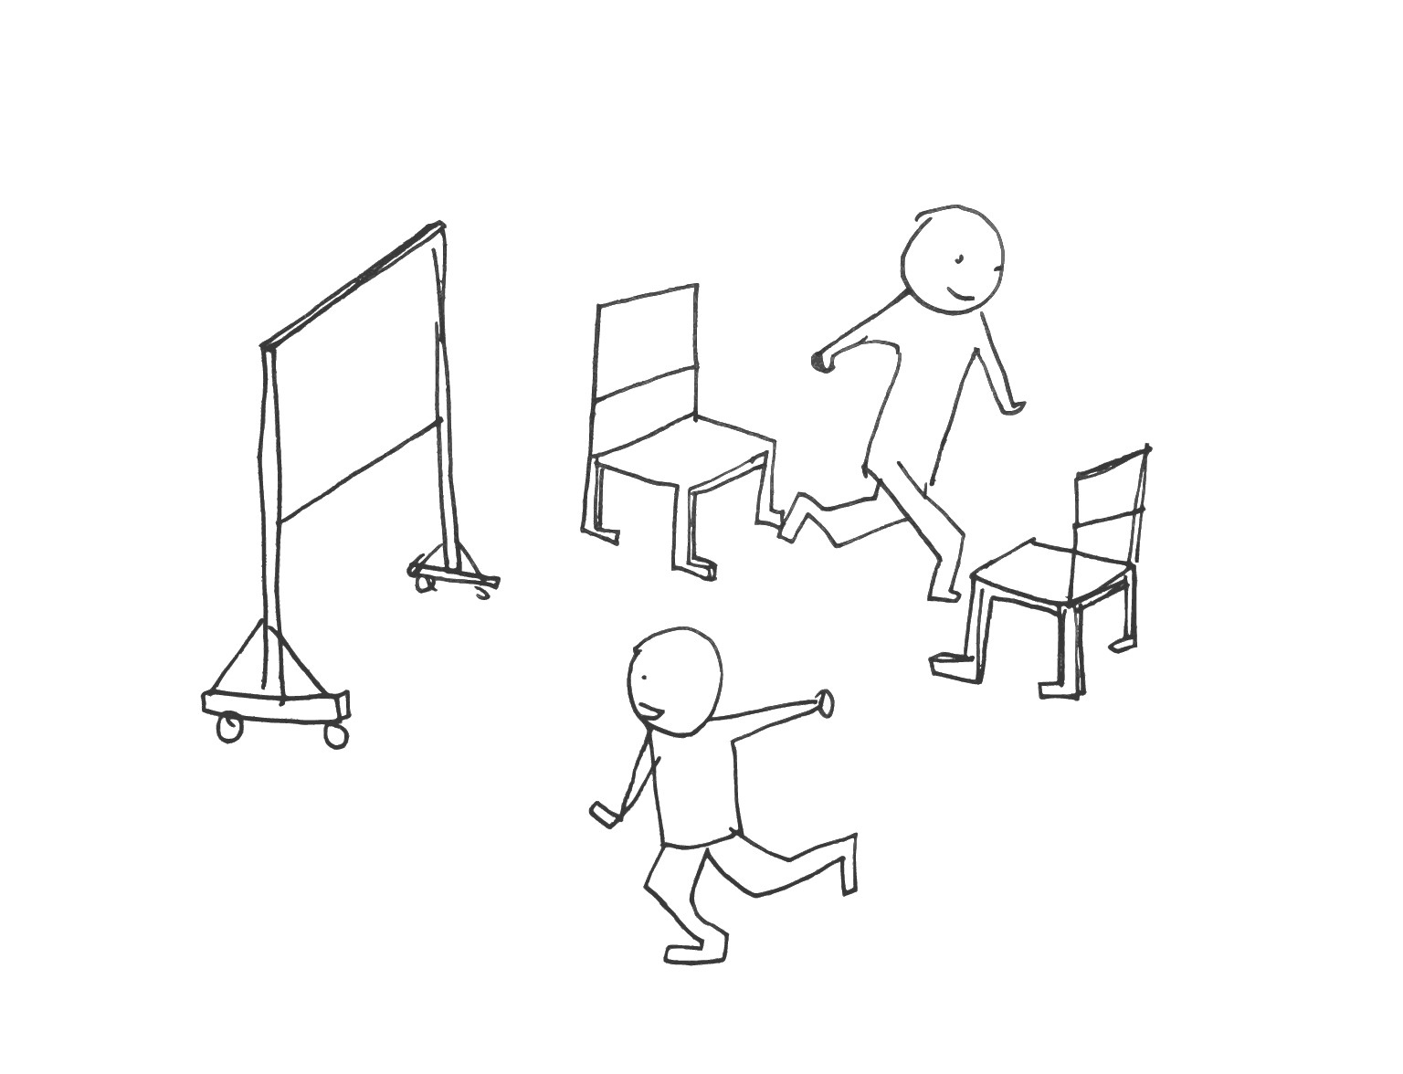

Feedback Survey

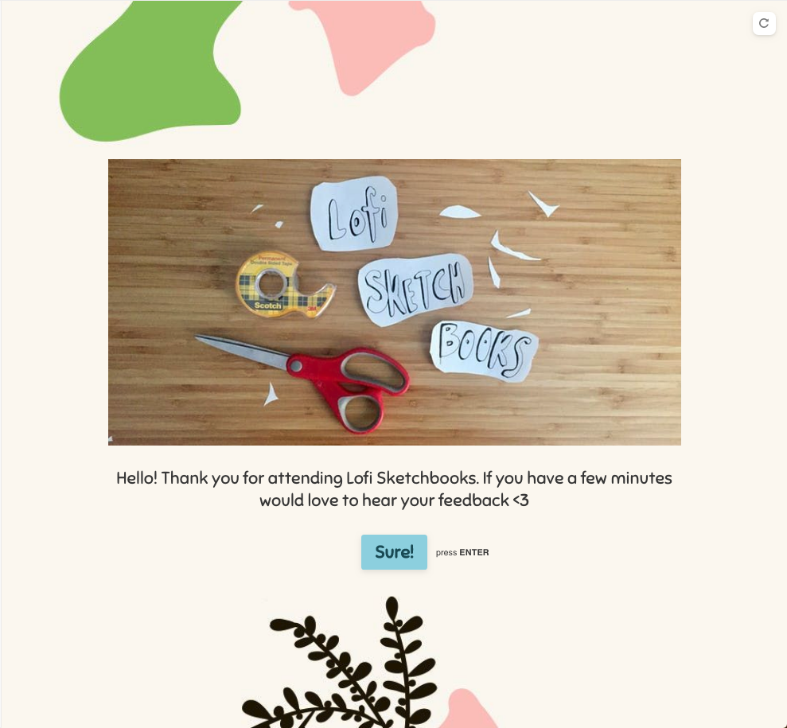

[TypeForm Survey](https://www.typeform.com/) (submitted by 4 of 12 / anonymous responses)

**How long the survey took & from what device style:**

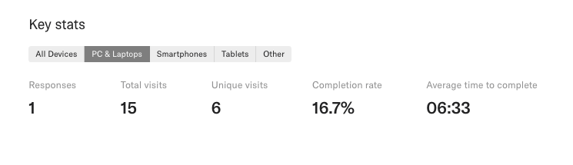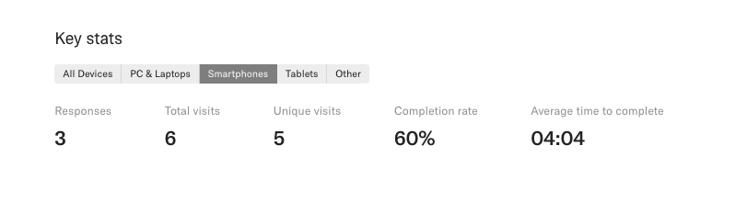

**Rating questions:**

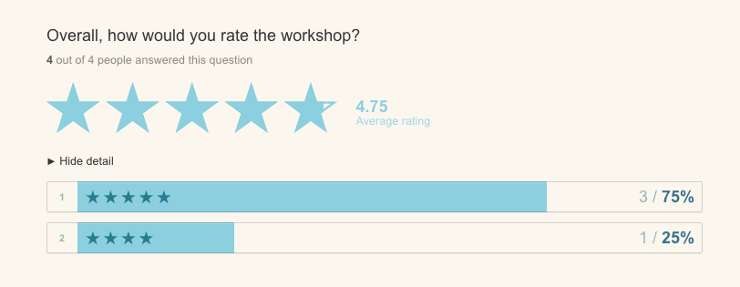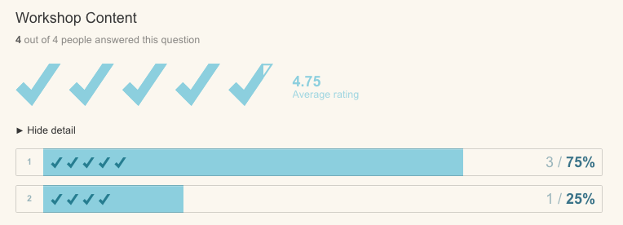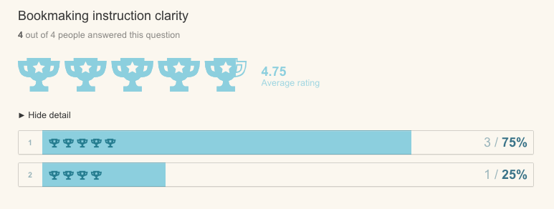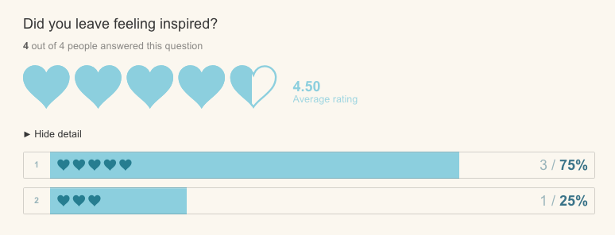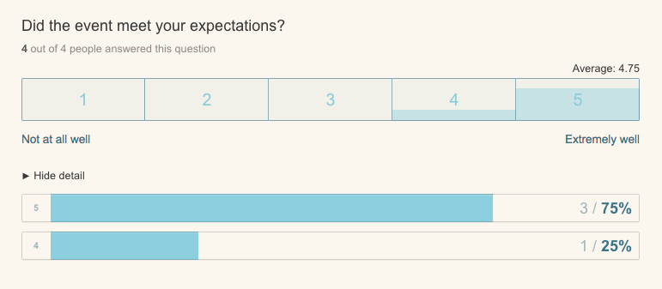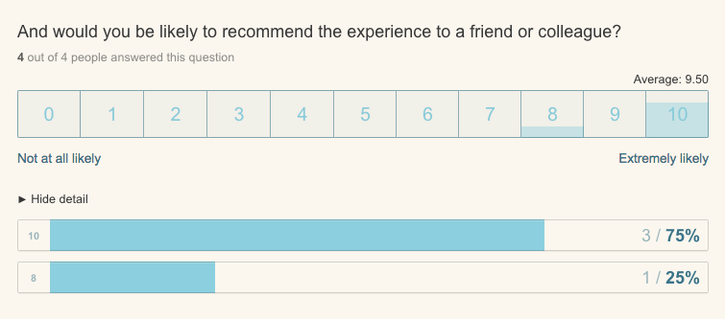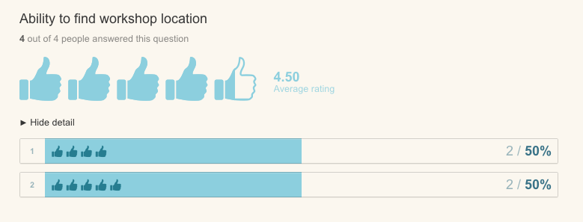

**Short Form Questions**

**1. Did you have a favorite moment or part of the workshop?**

* *Responses:*
  + *I though the energy in the room was great! This was largely due to your calmness and the flow of the workshop*
  + *When I put together the book and was able to see what my hands made.*
  + *Folding paper with instructions*
  + *Looking at the book examples including the epic accordion fold book.*

2. **Are there topics from the workshop you would like to learn more about?**

* *Responses:* 
  + *More advanced techniques of book making*
  + *Other simple ways to make books*
  + *More complex binding methods and examples of poetry books*

**3. Were there topics that you had hoped would be addressed that weren’t included in the workshop?**

* *Responses:*
  + *History of sketchbooking*
  + *Nope.*
  + *More about Lofi Contents*
  + *No*

**4. Any other feedback or advice for the Lofi Sketchbooks Workshop?**

* *Responses:*
  + *You are great :)*
  + *Maybe different type of Stationary*
  + *One more type of book style would have been spectacular*

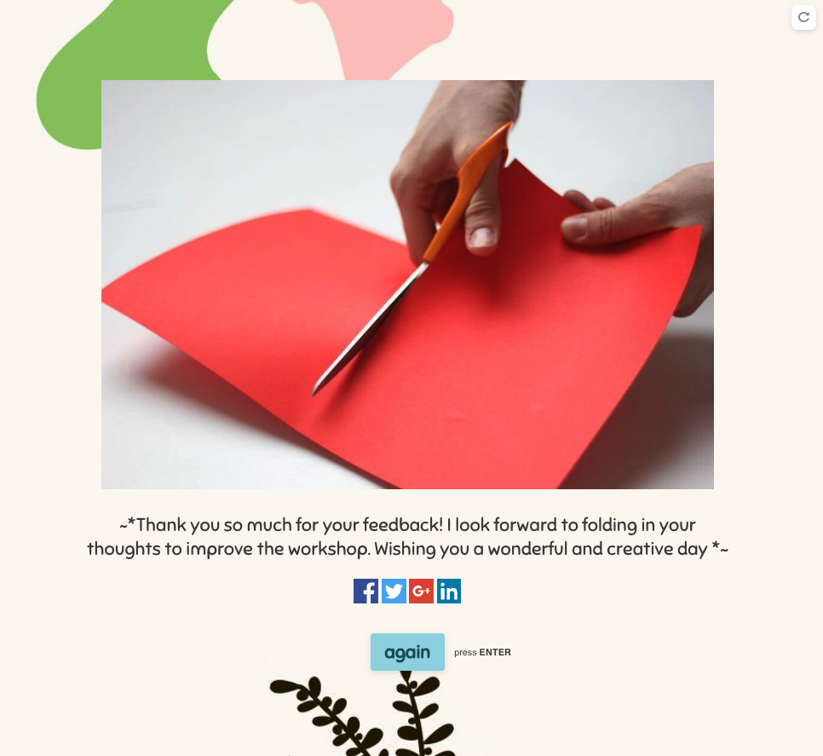

Personal Reflection + Feedback to fold in this coming week

Putting together any workshop or facilitating a conference always makes me appreciate on an even deeper level teachers I’ve had or know. This process really helped me make sure to constantly fold in feedback over the course of a few weeks and was interesting developing it out after collaborating the first? I think this may be the first experience I’ve had of rapid prototyping a workshop? it took a little longer to think about / adjust the original idea from initial collaboration & scale it to 1 hour when the bookmaking workshops I’ve assisted or experienced are about 3-5 hours, or over a couple sessions. Thinking about how to balance the simplicity of making for that time frame in a way that still felt creatively challenging enough for the participants was a good exercise. I really enjoyed using the typeform survey & Taeyoon mentioned to include a physical survey at the end of the workshop for the last 5 minutes as a more reliable possibility (would like to do that next time). In the way that our ITP teachers will allocate time for us to fill out their surveys, but leave the room so we don’t feel a biased pressure.

I would like to fold in the feedback I received from the past few days through the survey into the syllabus / slide presentation. Maybe a couple slides of the history of sketchbooks for context as well as instead of a prompt at the end? Use that time to show another format? So that 3 are given total, and can have a small little square of paper with some prompt ideas for participants to walk away with. I’d also like to trim & distill the description, maybe creating a shorter one for event pages and the longer one as a sort of proposal that sets the tone for someone who is interested in running the workshop themselves. Would also like to have my own walkthrough tutorial pdfs done in my own hand verses forwarding a found one? And would encourage any future facilitator to do the same too.

*comb through overall to edit down & format for future facilitators // I’ve also had a recent experience when going through documentation of a workshop where one of the main elements wasn’t included? So incase slides were to get separated from this document? Will include thumbnails after

*initially folded in feedback from 2 test runs to include a prompt to activate the sketch book space & also to really fluff out the presentation with more examples that speak to multiple ways of making

*Future Thumbnail / Contact Sheet of Slides*

